Housing Needs Assessment
Keele
August 2017
Proof Read draft

Contents
Glossary of terms used in text 5

Executive Summary 6

Recommendations for next steps 14

1 Introduction 11

2 Approach 11

3 Relevant Data 19

4 Conclusions 56

Limitations
AECOM Infrastructure & Environment UK Limited (“AECOM”) has prepared this Report for the sole use of Keele Parish Council (“Client”) in accordance with the Agreement under which our services were performed. No other warranty, expressed or implied, is made as to the professional advice included in this Report or any other services provided by AECOM.
Where the conclusions and recommendations contained in this Report are based upon information provided by others it is upon the assumption that all relevant information has been provided by those parties from whom it has been requested and that such information is accurate. Information obtained by AECOM has not been independently verified by AECOM, unless otherwise stated in the Report.
The methodology adopted and the sources of information used by AECOM in providing its services are outlined in this Report. The work described in this Report was undertaken in the period November 2016 to July 2017 and is based on the conditions encountered and the information available during the said period of time. The scope of this Report and the services are accordingly factually limited by these circumstances.
Where assessments of works or costs identified in this Report are made, such assessments are based upon the information available at the time and where appropriate are subject to further investigations or information which may become available.
AECOM disclaim any undertaking or obligation to advise any person of any change in any matter affecting the Report, which may come or be brought to AECOM’s attention after the date of the Report.
Certain statements made in the Report that are not historical facts may constitute estimates, projections or other forward-looking statements and even though they are based on reasonable assumptions as of the date of the Report, such forward-looking statements by their nature involve risks and uncertainties that could cause actual results to differ materially from the results predicted. AECOM specifically does not guarantee or warrant any estimate or projections contained in this Report.
Where field investigations are carried out, these have been restricted to a level of detail required to meet the stated objectives of the services. The results of any measurements taken may vary spatially or with time and further confirmatory measurements should be made after any significant delay in issuing this Report.
Copyright
© This Report is the copyright of AECOM Infrastructure & Environment UK Limited. Any unauthorised reproduction or usage by any person other than the addressee is strictly prohibited.

Project Role | Name | Position | Actions Summary | Signature | Date
Researcher(s) | Tony Sloan | Graduate Planner | Research and drafting | TS | 10/01/17
Project Manager | Ivan Tennant | Principal Planner | Drafting and review | IT | 10/01/17&  27/06/17
Director/QA | Stuart Woodin | Technical Director | Technical Review | SW | 14/01/17
Qualifying Body | Graham Bibby | Chair, Keele Parish Council |  | GB
Project Coordinator | Jessica Boekhoff | Consultant | Proof-read | JB

Glossary of terms used in text
DCLG Department for Communities and Local Government
NP Neighbourhood Plan
NuL (BC) Newcastle-under-Lyme (Borough Council)
LPA Local Planning Authority
HNA Housing Needs Assessment
KPC Keele Parish Council
NPA Neighbourhood Plan Area
NPPF National Planning Policy Framework
ONS Office for National Statistics
PPG Planning Practice Guidance
SHMA Strategic Housing Market Assessment 2015
SHMAU Strategic Housing Market Assessment Update 2017
PRS Private Rented Sector

Executive Summary

Introduction
- The 2011 Localism Act introduced neighbourhood planning, allowing parishes, town councils or neighbourhood forums across England to develop and adopt legally binding development plans for their neighbourhood area.
- As more and more parishes, towns and urban forums seek to address housing growth, including tenure and type of new housing, it has become evident that developing policies need to be underpinned by robust, objectively assessed housing data.
- In the words of the national Planning Practice Guidance (PPG), establishing future need for housing is not an exact science, and no single approach will provide a definitive answer. The process involves making balanced judgments, as well as gathering numbers and facts. At a neighbourhood planning level, one important consideration is determining the extent to which the neighbourhood diverges from the local authority average, reflecting the fact that a single town or neighbourhood almost never constitutes a housing market on its own and must therefore be assessed in its wider context.
- The guidance quoted above on housing needs assessment is primarily aimed at local planning authorities preparing Strategic Housing Market Assessments (SHMAs), which are used to determine housing need at a local authority level. However, it helpfully states that those preparing neighbourhood plans can use the guidance to identify specific local needs that may be relevant to a neighbourhood, but that any assessment at such a local level should be proportionate.
- Our brief was to advise on data at this more local level to help Keele Parish Council understand, among other matters, the type, tenure and quantity of housing needed to inform neighbourhood plan policies.

PPG-Based Assessment
- This objective and independent housing needs advice note follows the PPG approach where relevant. This ensures our findings are consistent with industry standards and the evidence sources are appropriate. The PPG advises that assessment of housing needs should be thorough but proportionate and does not require planners to consider purely hypothetical future scenarios, only future scenarios that could be reasonably expected to occur.

Summary of Methodology
- Housing Needs Assessment at neighbourhood plan level can be focused either on quantity of housing needed, type of housing need, or both. In most cases, there is a need to focus on quantity where the housing target for the settlement being assessed is unclear, for example where the local authority has not set a specific target for the settlement, or where there is no local plan in place.
- In the case of Keele, the current adopted Development Plan, the Joint Core Spatial Strategy does not provide a specific housing target for the Keele Parish. The SHMA, published in 2015 and updated in 2017, provides the evidence base for the emerging Joint Local Plan. This too does not provide clear housing targets for the sub-areas that make up the Newcastle-under-Lyme/Stoke-on-Trent Housing Market Area; it is therefore not possible to extract from this document a number for housing in Keele that will address future need. The core purpose of this study is therefore to consider both quantity of housing needed as well as type, in accordance with the wishes of the Parish Council.
- The rationale for this recommended approach is that neighbourhood plans need to pass a number of ‘Basic Conditions’ to be adopted. One of these, Basic Condition E, requires the Neighbourhood Plan to be in ‘general conformity with the strategic policies’ of the Local Plan, in this case the Joint Core Spatial Strategy (JCSS) for Newcastle-under-Lyme and Stoke-on-Trent. The Government’s Planning Practice Guidance indicates that policies that relate to housing in terms of quantity and provision of affordable homes, are likely to count as strategic.
- In terms of the types of housing needed, there is generally more flexibility on what neighbourhood plans can cover. In order to understand the types of housing needed in Keele, we have gathered a wide range of local evidence and summarised it into policy recommendations designed to inform decisions on housing quantity and characteristics.
- The planning period of neighbourhood plans, where possible, should be aligned with the relevant local plan. In the case of Keele, the SHMA covers a planning period of 2013-39; and we have assumed the NDP falls into line with this.

Gathering and Using a Range of Data
- The PPG states that:
The Government’s PPG stresses the importance of using a variety of sources of information, but limiting expenditure on disproportionate primary research (information that is collected through surveys, focus groups or interviews etc. and analysed to produce a new set of findings). Planners should instead look to rely predominantly on secondary data (e.g. Census, national surveys) to inform their assessment which are identified within the guidance’.
- Compared with the 2001 Census, the 2011 Census gathered data in a number of new categories and across a range of geographies that are highly relevant to planning at the neighbourhood level and helpful if a PPG-based approach is being used.
- Like much of the data forming the housing policy evidence base, the Census information is quantitative. However, at a local level, qualitative and anecdotal data, if used judiciously, also has an important role to play, to a perhaps greater extent than at local authority level. We have gathered data from as wide a range of sources as practicable in order to ensure robustness of conclusions and recommendations arising from the analysis of that data. Our conversation with local estate agents, Rockett Rentals and Butters John Bee (taking place on 19th December 2016), helped ensure our conclusions were informed by a qualitative, local perspective.

Focus On Demand Rather Than Supply
- Our approach is to provide advice on the housing required based on need and/or demand rather than supply, in line with PPG advice.
- For this reason, we advise that the conclusions of this report should go on to be assessed against supply-side considerations (including, for example, factors such as transport infrastructure, landscape constraints, flood risk and so on) as a separate and follow-on study.

Quantity of Housing Needed
- Our assessment of a wide range of data sources identified five separate projections of dwelling numbers for Keele between 2013 and 2033 based on:
- A figure derived from the Adopted 2009 Joint Core Spatial Strategy (JCSS) for Newcastle-under-Lyme and Stoke-on-Trent. This provides a forecast of zero dwellings given that the JCSS states that no further development is planned in the villages within the HMA, of which Keele is one;
- A ‘proportionate share’ derivation from the 2017 Strategic Housing Market Assessment Update (SHMAU), Objectively Assessed Need (OAN) produces a figure if 63 dwellings to be delivered over the Plan Period, or 3 (rounded) dwellings per year;
- DCLG Household Projection of 67 dwellings, or 3 dwellings (rounded) to be delivered over the Plan Period;
- A projection forward of net dwelling completion rates 2001-2011, (which gives a projection of 88 dwellings, or 4 dwellings per annum; and
- A projection forward of net dwelling completion rates 2011-2015 (which gives a projection of 44 dwellings to 2026, or 2.2 dwellings per annum).
- These dwelling number projections are illustrated in Figure 1 below.

Figure 1: Dwelling projections for the Keele NP Area, 2011-2031

- The graph above (the vertical axis indicates the number of homes) sets out the total number of homes factoring in each of the projections we have identified in paragraph 17. So, for example, factoring in SHMAU derived data (green line) to the number of dwellings that have already been built in the plan area between 2011 and 1st January 2016 (10) produces a total demand for 513 homes over the plan period.
- We have applied our professional judgment on the scales of increase and decrease associated with each factor on a scale from one to three, where one arrow indicates ‘some impact’, two arrows ‘stronger impact’ and three arrows indicates an even stronger impact. Factors are in alphabetical but no other order.
Table 1: Summary of factors specific to Keele NP with a potential impact on neighbourhood plan housing quantity
Factor | Source(s) (detailed in Chapter 3) | Possible impact on future housing need | Rationale for judgement
House prices | SHMA, SHMAU | ↑ | Our findings suggest a steady growth in prices, with some evidence that prices are starting to outstrip household income. One upward arrow has therefore been applied to underpin affordability in future years.
Volume of Transactions | Local Agents, Community surveys, SHMA | ↑ | The lack of suitable stock is the principal reason why demand displacement is taking place; in particular young families who would prefer to live in Keele, but who cannot do so on account of dwellings only rarely coming onto the market. For this reason, one ‘up’ arrow has been applied.
Overcrowding | Census | ↔ | Despite the absence of overcrowding (which would normally suggest weak demand) we do not see this as justifying an increase or decrease in the supply of dwellings on account of the existence of other data that suggests this is more likely to do with, firstly, demand displacement and, secondly, the occupation of dwellings by older residents who might downsize, were there the opportunity to do so.
Vacant Dwellings | SHMA | ↑ | The low level of vacant dwellings suggests high demand for housing in the NPA; for this reason, one ‘up’ arrow has been applied.
Employment trends |  | ↑↑ | Bearing in mind the recommendations in the SHMAU that housing policy should seek to provide suitable housing for younger households so as to address exclusion and support economic growth, the data we have gathered relating to employment growth suggests the prospect of substantial numbers of jobs being created both associated with the University (and therefore either inside the Parish or a short commuting distance from it), or within growth poles that lie within reasonable commuting distances. For this reason, we have applied two 'up' arrows.

- In arriving at a final figure for homes that reflect demand in the NPA two issues need to be taken into consideration. Firstly, the number derived from dwellings completed in paragraph 17 (item 4) is supply constrained, meaning that they reflects the difficulty of actually delivering new homes on the ground as a result of environmental factors and standing policy. This makes these figures less reliable as a guide to demand in places like Keele where demand significantly outstrips what can be delivered in practice. Moreover, the SHMAU, produced in 2017, offers the most considered and up-to-date source of evidence available as regards to housing need at district level such should be accorded substantial weight. Secondly, it is necessary to take into account the influence of the factors set out in Table 1.
- In order to allow for the first of these factors, we have taken the mean of projections 2 and 3 only as the basis for our final estimate. This produces a rounded figure of 65 homes. Taking the second factor into consideration, we look at the balance of ‘up’ to ‘down’ arrows. Our study has noted a balance in favour of ‘up’ arrows of 5. The argument in favour of increasing the housing target for the NPA is based primarily on the strength of prospective jobs growth. Bearing this in mind, together with the specific recommendation in the SHMAU for plan-makers to support housing for younger families, we suggest an uplift of 10%; this produces a final figure of 72 dwellings (rounded) to be delivered in the NPA over the Plan Period of 2013 – 33.
Table 2: Summary of local factors specific to Keele NP with a potential impact on housing Type
Factor | Source(s) (see Chapter 3) | Possible impact on housing needed | Conclusion
Affordable Housing (AH) | SHMA, Housing Waiting List data, CACI pay-check data | The evidence to support the provision of AH in the NPA is weak.  There is little scope, on the basis of the evidence gathered, of departing from Local Plan policy as regards AH.  Household incomes suggest Starter Homes would be appropriate. | Notwithstanding, Housing Waiting List data suggests very little need for AH emanating from the Parish, certainly an insufficient quantity to justify the NPA setting a AH policy that departs from that the currently adopted Local Plan.  Based on a 'fair share' calculation however, the NPA may seek to deliver 17 affordable homes over the Plan Period. These may be apportioned according to Local Plan policy (60/40 social/intermediate split) with a proviso the new AH types coming forward as part of the Government’s planning reforms will introduce the opportunity for a more locally specific response, but this will require evidence of local need.  Given household income levels in the NPA, it is likely intermediate AH products, such as Starter Homes and Affordable Private Rent, would enable younger households to access market housing.  The absence of any AH waiting list in Keele may be explained by AH tending to concentrate in more urban locations.
Demand/need for smaller dwellings | Census, SHMAU | Census data and forecasts spanning the plan period indicate a growth in solo households, and a substantially ageing population. | The NPA is forecast to see an increase in solo households, generating a need for smaller dwellings, with a proviso the relationship between this household type and ‘size of dwellings’ is weak.  Keele is unlikely to escape the trend, seen across the country as well as at the district level, of an increase in the proportion of the population over age of 65. This suggests sheltered housing, extra care dwellings and ‘Lifetime Homes’ principles should be considered.  Given the size of the settlement, any specialist housing for older people should be discussed with the LPA with an eye to addressing need across the district.
Demographic change | Census, SHMAU | Removing student numbers that ‘skew’ the data, the age structure of Keele and the wider NuL are similar.  Census data suggests a modest exodus of young adults. | The age structure of Keele suggests broad similarities with the wider district, indicating forecast demographic change set out in the SHMAU is likely to be similar between the two geographies.  The shrinking share of the population accounted for by those aged 25-44 should be a cause for concern, as this, if it continues, could threaten the vitality and viability of the settlement.  The increasing numbers of the elderly will create an obligation to provide housing suited to their needs.
Family-sized housing | Census, SHMAU, Housing Monitoring Reports | Size of dwellings in the NPA shows a strong bias towards larger dwellings.  There have been relatively few new dwellings delivered in recent years. | Without the provision of dwellings suited to younger families, of 4 and 5 rooms, Keele could become polarized into wealthy, increasingly elderly households living in large houses on the one hand and the student community on the other, with nothing in between. Working house-holds living on modest incomes, with and without children, will be missing from the picture.  The apparent equilibrium in the local housing market, observed through the lack of over-crowding and concealed households, may be a mis-reading of the market signals; the lack of available homes (exacerbated by weak supply in recent years) may simply result in a displacement of demand to other surrounding areas.
Tenure of housing | Census | Growth in Private Rented Sector (PRS) housing.  Limited opportunity to deliver additional AH.  Affordable market housing (AMH) is within reach of those on mean incomes. | There has been a sharp increase in PRS, and this is likely to act as a substitute for Affordable Housing.  Within larger schemes, build to rent should be supported.  The market mechanism should be supported to deliver affordable market housing.
Student Housing | SHMA, Census; Keele University’s Strategic Plan 2015-2020 | Keele University has expansion plans that envisage expanding the student population by 3000 | While there is an estimated need to house around 650 students 'off campus', given the wide distribution of student households across the district, and the preference of undergraduates in particular to live close to urban centres, we see the impact of this growth as being limited to the extent that no specific provision for students is identified within this HNA.

Recommendations for next steps
- This neighbourhood plan housing needs advice has aimed to provide Keele Parish Council with evidence on housing trends from a range of sources. We recommend that the Parish Council should, as a next step, discuss the contents and conclusions with Newcastle-under-Lyme with a view to agreeing and formulating draft housing policies, taking the following into account during the process:
- the contents of this report, including but not limited to Tables 1 and 2;
- Neighbourhood Planning Basic Condition E, which is the need for the neighbourhood plan to be in general conformity with the emerging development plan (here, the Emerging Joint Local Plan);
- the views of the Borough Council;
- the views of local residents (as recorded in a Consultation Statement showing how housing policies reflect these views);
- the views of other relevant local stakeholders, including housing developers; and
- the numerous supply-side considerations, including local environmental constraints, the location and characteristics of suitable land, and any capacity work carried out by the Council, including but not limited to the SHLAA.
- As noted previously, recent changes to the planning system, as well as forthcoming changes to the National Planning Policy Framework as well as the implementation of the Housing and Planning Act 2016, will continue to affect housing policies at a local authority and, by extension, a neighbourhood level.
- This advice note has been provided in good faith by AECOM consultants on the basis of housing data current at the time of writing (alongside other relevant and available information).
- Bearing this in mind, we recommend that the steering group should monitor carefully strategies and documents with an impact on housing policy produced by the Borough Council or any other relevant body and review the neighbourhood plan accordingly to ensure that general conformity is maintained.
- Most obviously, this includes monitoring the status of the Emerging Joint Local Plan.
- At the same time, monitoring ongoing demographic or other trends in the factors summarised in Tables 1 and 2 would be particularly valuable.

1 Context

Local context

- Keele is a village in northern Staffordshire, with a parish population of 4,129 (2011 Census). It is approximately three miles west of Newcastle-under-Lyme and approximately four and a half miles west of Stoke-On-Trent. The local authority for Keele is Newcastle-Under-Lyme Borough Council (NuL). Keele lies north of the M6, between Junctions 15 and 16 providing fast road links to the rest of the North West and the Midlands. Keele is the location of Keele University; this important educational institution lies both within and adjacent to the village.

- The closest train station is located in Stoke-on-Trent; this station is on the West Coast Main Line. This route links Greater London, the West Midlands, the North West, North Wales and the Central Belt of Scotland. The nearest major airport is Manchester Airport.

- For planning purposes, the Development Plan covering the area currently consists of the Newcastle-under-Lyme and Stoke-on-Trent Core Spatial Strategy (adopted 2009) and saved Local Plan Policies (adopted 2003). The Core Spatial Strategy only contains housing targets for Newcastle and Stoke.

- The Borough is in the process of preparing a new Joint Local Plan for Newcastle-under-Lyme and the City of Stoke-on-Trent (currently at Issues Consultation stage). This new Joint Plan will eventually replace the existing Joint Core Spatial Strategy (adopted 2009).

- Keele is part of the Stoke-On-Trent Newcastle-under-Lyme Housing Market Area, and as such the Stoke-On-Trent Strategic Housing Market Assessment (SHMA) is relevant to this housing needs analysis and will be interrogated as appropriate.

Planning policy context
Emerging Joint Local Plan for Newcastle-under-Lyme and Stoke-on-Trent (2015) – Issues Consultation Document (February – March 2016)
- Stoke-on-Trent City Council and Newcastle-under-Lyme BC are preparing a new JLP that will eventually replace the existing JCSS. In 2016, the councils consulted on the strategic issues for the JLP to address. The consultation document identifies a number of key housing issues. We have identified a number of points below that show both the commonalities, but also contrasts with Keele,
- Housing Need – as noted above, SHMA has identified an OAN ranging from 1,177 to 1,504 dwellings per annum across both authorities between 2013 and 2039. This is substantially above the requirement previously set in the JCSS, which had an indicative annual target for 855 dwellings across both areas (to meet the lower figure will require a 27% uplift).
- Outmigration and natural population decline - The population in Stoke-on-Trent is naturally increasing due to a high birth rate, whilst the population in Newcastle-under-Lyme is ageing. The HMA struggles to retain graduates who might be the potential high earners of the future, deterring investment in quality jobs. To improve economic competitiveness and attract and retain residents, higher levels of house building will be required.
- A weak housing market - continues to impact on the number of houses that have been built. The viability of development sites continues to be a significant challenge. The current strategy of targeted regeneration has maintained a supply of housing but this has not been enough to meet needs due to market factors, including the high cost of bringing some sites forward.
- Affordable Housing - The private rented sector is meeting some of the needs for affordable housing but does not always provide housing of an appropriate quality. There is evidence of property prices out-stripping incomes in the area; as a result, there is a need for affordable housing to be built, including in rural areas.
- Specialist Housing Need - Specialist accommodation is required to meet the needs of an increasing number of elderly persons. High value housing is also required to attract a skilled and well paid workforce, but more evidence is needed to understand what the implications are locally. The number of university students is expected to increase and this will increase the need for student accommodation, some of which may have to be met by the private rented sector. Over the plan period a total of 7 new permanent pitches and 5 transit pitches are required in Newcastle-under-Lyme to meet the needs of Gypsies and Travellers.
- As identified earlier, the JLP is not at a sufficiently advanced stage such that a housing target has been identified. Therefore it is not possible to derive a projection for the NP from the JLP at this point in time.
Joint Local Plan Issues Consultation - Housing Technical Paper (2015)
- A number of technical papers were prepared to summarise and interpret the evidence that led to the identification of the issues for the JLP to address. These papers were published alongside the Issues Consultation Document.
- As identified earlier in this report, the Housing Technical Paper notes that the JCSS housing targets may no longer accurately reflect housing needs, and that the recently prepared SHMA (2015) and SHMAU (2017) form the starting point for identifying a new figure for housing need which would be compliant with national planning policy. The Paper sets out a useful summary of housing strengths and weaknesses in the HMA, drawing from the analysis in the SHMA.
- The Technical paper also notes that historically, there has been a substantial gap between the number of dwellings which have been permitted and the completions delivered in the housing market area over the same period – a challenge for both the LPA and Neighbourhood Planning Groups.

2 Approach

Research Questions
- Housing Needs Assessment (HNA) at neighbourhood plan level can be focused either on quantity of housing needed, type of housing need, or both. In most cases, there is a need to focus on quantity where the housing target for the settlement being assessed is unclear, for example where the local authority has not set a specific target for the settlement, or where there is no local plan in place.
- As we have seen, in the case of Keele, the most recently adopted Development Plan is out of date, and indeed, does not provide any guidance on housing numbers for the neighbourhood beyond stating that no further growth is planned for rural settlements (of which Keele is one).

Quantity
- It is therefore necessary to arrive at an estimate for the required housing growth relying on a number of reliable sources; these are:
- A number derived from the JCSS;
- Strategic Housing Market Assessment Update 2017;
- DCLG Household projections;
- Net dwelling completion rates 2001-2011; and,
- Net dwelling completion rates 2011-2015.
- In addition to the question of quantity, is it important to break this down to enable policy to be developed that reflects current and projected Parish need. This part of the study will consider the tenure, type and size of dwellings. Finally, we also consider the requirement for ‘specialist’ housing suited to the needs of niche groups. The key research questions can be summarised as follows,
- Given income levels within the area what tenures of housing are appropriate?
- The demographic of the area displays a wide variety of different people at different stages in life, for example housing is needed by young adults, the student community as well as retirees. To what extent should these groups be taken into consideration in developing policy and, if so, what type and size of dwellings would be appropriate?

Study Objectives
- The objectives of this report can be summarised as:
- Collation of a range of data with relevance to housing need in Keele relative to Newcastle-under-Lyme;
- Analysis of that data to determine patterns of housing need and demand; and
- Setting out recommendations based on our data analysis that can be used to inform the Neighbourhood Plan’s housing policies.
- The remainder of this report is structured around the objectives set out above:
- Chapter 3 sets out the data gathered from all sources; and
- Chapter 4 sets out our conclusions and recommendations based on our data analysis that can be used to inform the Neighbourhood Plan’s housing policies.

3 Relevant Data

Local Planning Context
- The PPG states that neighbourhood planners can refer to existing needs assessment prepared by the local planning authority as a starting point. As Keele Parish Neighbourhood Plan (KPNP) is located within the Stoke-on-Trent and Newcastle-under-Lyme Housing Market Area, we therefore turned to the Stoke-on-Trent City Council and Newcastle-under-Lyme BC Strategic Housing Market Assessment, July 2015, (henceforth ‘SHMA’) and SHMA Update June 2017 (henceforth ‘SHMAU’) which cover the housing market area and informs emerging housing policies at a local authority level, including affordable housing policy.
- The SHMA documents draw upon a range of data including population projections, housing market transactions and employment scenarios to derive the objectively-assessed housing need. As such, it contains a number of points of relevance when determining the degree to which the housing needs context of Keele itself differs from the authority-wide picture.
- For the purposes of finer-grained analysis across such a large HMA, the SHMA divides the housing market area into a number of smaller local sub-markets. The NP area is conveniently one such sub-area. Figure 2.1 of the SHMA, which defines the boundaries of the sub-areas, is reproduced as Figure 2 below.
Figure 2: the Newcastle-under-Lyme, Stoke-on-Trent HMA
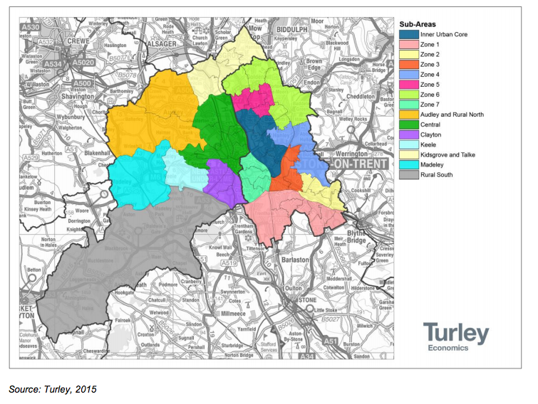
- The evidence indicates there are clear areas of higher and lower value in Newcastle-under-Lyme, and that Keele represents are area of relatively high property values when compared with the more urban parts of the local authority area.
Research questions
- To follow, we have set out a summary of the evidence we have gathered to respond to the research questions established in Chapter 2.
Quantity
- We have estimated the quantity of housing needed in Keele according to four different sources; these are,
- A figure derived from policy set out in the Joint Core Spatial Strategy for Stoke-on-Trent City Council and Newcastle-under-Lyme BC (JCSS) (Adopted October 2009), the current adopted Local Plan for the local authority area;
- Strategic Housing Market Assessment Update 2017 (SHMAU);
- DCLG Household projections;
- Net dwelling completion rates 2001-2011; and,
- Net dwelling completion rates 2011-2015.

These sources and the corresponding calculations are set out below.
- JCSS
- The focus of the JCSS is on delivering housing primarily in areas which support the overarching principle of targeted regeneration. This channels all development towards the highest priority areas – i.e. the city and town centres and areas identified for priority intervention and regeneration (the most deprived areas of the borough and city) and dictates a policy of restraint within non-priority locations. Similarly, there is a prioritisation towards previously developed land in order to deliver “effective and sustained regeneration.” This ‘targeted regeneration’ is set out in Policy SP1 - Spatial Principles of Targeted Regeneration.
- The JCSS sets a housing requirement for 5,700 additional dwellings (net) (285 dwellings per annum) in Newcastle-under-Lyme (see page 43). In terms of affordable housing, the target is to deliver 1,200 dwellings in Newcastle-under-Lyme, broken down into a specified mix of 60% Social Rented, and 40% Intermediate Housing. The document defines Keele as one of the region’s villages; for these settlements, the document states that no further housing growth is planned; from this it is reasonable to arrive at a housing target of 0.
- July 2015 SHMA
- The Keele parish asked AECOM to consider what the potential range of housing need for the NP area might be. As the emerging JLP is not at a sufficiently advanced stage that an indicative target for housing delivery is available, either at the NP area or the local authority level, it is appropriate to turn to the latest evidence of what that need might be, as a starting point for considering need at the NP level. This evidence is contained within the SHMA and SHMAU that has been prepared to inform the development of housing policies in the emerging JLP.
- It is important to remember that the SHMA presents a ‘policy off’, or unconstrained assessment of need (often identified as Objectively Assessed Need, or OAN), as opposed to a final housing target, which will take into account a number of other factors, including but not limited to, the availability of land, viability, infrastructure and environmental constraints and the results of consultation. Nonetheless, the SHMA presents an appropriate starting point for deriving need at the NP level, because it is the most up-to-date evidence available, and importantly, because it takes into account the latest population and household projections, as set out in the 2012-based National Household Projections (NHHP) and 2012 Sub-National Population Projections on which the Household Projections are based, which the PPG guidance suggests should be taken as a ‘starting point’ in determining need at the local authority level.
- The SHMA identifies a range of potential housing need between 1,177 dwellings per annum (367 per annum to be found in Newcastle-under-Lyme) and 1,505 dwellings per annum over the period 2013 – 2039 (target not disaggregated by individual local authority). The first figure represents a ‘demographic adjusted’ level of need. The second figure is an ‘uplifted’ figure, which takes into account economic growth projections for the HMA, as well as the need to increase housing supply in order to improve affordability of housing. The SHMAU takes this ‘range’ to an objectively assessed need (OAN) for 1,390 dwellings per annum.
- The SHMAU update does not state how this should be split between Newcastle under Lyme and Stoke on Trent. For the purposes of this study we have therefore assumed the same proportional allocation as the SHMA, which suggested the figure of 1,177 dwellings should be split between the two authorities with 367 dwellings being allocated to NuL and 810 to SoT. Expressed as percentages, this is 31% and 69%. Using the same proportions, it is possible to derive a housing figure for NuL of 431 dwellings per annum (rounded)

- Keele represents 0.812% of housing in the NuL area (440 expressed as a % of 54,220); taking 2013 as the base year to be consistent with the SHMA, the plan period is 26 years (2013 – 2039). The overall housing target expressed in the SHMAU equates to 431 dwellings/year = 3.5. On this basis, Keele requires 70 new homes (3.5x20) over the Plan Period. It is however necessary to take into account those dwellings that have been delivered since 2013.

- Between 1st April 2011 and the 30th September 2015, 10 (rounded) net new dwellings have been completed (the end of September 2015 represents the latest available data on completions as supplied by NuLBC). This equates to an annual rate of delivery of 2.2 dwellings (10 divided by 4.5, the number of years elapsed). Therefore, allowing for the three years that have elapsed, 7 dwellings should be deducted from the 70, producing a final figure based on the SHMAU of 63 dwellings to be delivered over the Plan Period, or 3 (rounded) dwellings per year.

- DCLG Household Projections
- The Department for Communities and Local Government (DCLG) periodically publishes household projections. The NPPG recommends that these household projections should form the starting point for the assessment of housing need.
- The most recent (2014-based) household projections were published in July 2016, and extend to 2039. Although population projections are only available at a local authority level, a calculation of the share for Keele is nevertheless possible for the household projections based on the village’s household numbers in the 2011 Census.
- At the 2011 Census, NuL had 52,574 households and Keele had 409 households, or 0.815% - of the NuL total.
- In the 2014-based household projections, the projection for 2033 is for 59,732 households in NuL. Assuming it continues to form 0.815% of the District total, Keele’s new total number of households would be 498; therefore 78 new households (rounded) form in Keele between 2011 and 2033 (or a rate of growth of 3.5 households per year).
- Given the Plan Period of 2013-33, two years’ worth of household growth needs to be deducted from the 78 households set out in the previous paragraph. This produces a new (rounded) total of 72 (78 – (3.2 x 2)).
- Number of
- households does not, however, equate precisely to number of dwellings, with the latter slightly higher in most places. Keele is no exception; in the 2011 Census, there were 409 households but 440 dwellings. This gives a ratio of 0.93 households per dwelling. In the case of Keele, then, a projection of 72 (83/0.93) new households translates into a need for 77 dwellings (rounded)
- Again, it is necessary to deduct the dwellings that have been completed, this time since 2011. Taking 2.2 as our rate of housing completions, this equates to 10 dwellings, producing a final number derived from DCLG Household projections of 67 dwellings, or 3 dwellings per annum (rounded) to be delivered over the Plan Period.
- This projection is an entirely unconstrained, theoretical figure comprising a relative proportion of the overall projected increase, and thus does not take into account political, economic, demographic or any other drivers that might have influenced, or may in future influence, the Local Plan distribution across the District and hence any difference between this figure and a future Local Plan-derived figure.
- Newcastle-under-Lyme Local Plan 2011 (Adopted October 2003) Schedule of Saved Policies beyond September 2007
- A number of saved policies from the Newcastle-under-Lyme Local Plan 2011 (adopted October 2003) remain part of the Development Plan for Newcastle-under-Lyme. It should be noted that a potential projection has not been drawn from this plan, as the policies in this Plan relevant to housing targets are no longer saved. For that purpose, we have looked to the JCSS. Just one development control policy remains relevant in so far as it forms part of the strategic context for the NP Steering Group when considering a potential target for the NP. This is policy H13, Supported Housing; this encourages supported or special needs housing in accordance with the Council’s Housing Strategy.
- Dwelling Growth 2001 – 2011
- Consideration of dwelling growth 2001-2011 provides a projection based on the rate of delivery of net new dwellings between the two censuses. There has been an increase of 44 dwellings in the NP area between the two censuses, or an annual rate of increase of 4.4 dwellings. For the plan period this would suggest a gross need for 88 dwellings over a plan period 2013-2033(20x 4.4), deducting the 10 dwellings completed since 2011 produces a revised figure of 78 dwellings, or 4 dwellings per annum.

- Dwelling Growth since 2011
- It is also helpful to consider a projection based on the rate of delivery of net new dwellings since the last census (2011), using data gathered and monitored by NuLBC. Between 1st April 2011 and the 30th September 2015, 10 (rounded) net new dwellings have been completed (the end of September 2015 represents the latest available data on completions as supplied by NuLBC). This equates to an annual rate of delivery of 2.2 dwellings (10 divided by 4.5, the number of years elapsed). If this rate of delivery was continued to 2033, this would equate to a projection of approximately 44 dwellings over the LPA plan period of 2013-2033 (2.2 x 20, rounded to the nearest whole number).

Tenure
- The PPG states that HNAs should investigate household tenure in the current stock and recent supply, and make an assessment, based on a reasonable interpretation of the evidence gathered, whether continuation of these trends would meet future needs or whether, on account of significant misalignments between supply of housing and local need/demand, policies should support a change to the profile of tenure within the NPA’s housing stock.

- It is also necessary to make clear the distinction between affordable homes as a piece of planning terminology and the colloquial definition of the phrase. In the course of this study, we refer to Affordable Housing, abbreviated to AH. We mean by this those forms of housing tenure that fall within the definition of AH set out in the National Planning Policy Framework (NPPF), social, affordable rented and various forms of intermediate housing. To distinguish this from the colloquial definition, we refer to the latter as Affordable Market Housing (AMH).

- Current stock
- Table 3, showing the range of tenures in 2011, indicates that the proportion of socially rented housing in Keele (21.8%) is higher than the numbers for the district (18.7%) and national (17.7%) level; the proportion of private rented housing (13%) is higher than the local average (10.5%) but lower than the national (16.8%); the proportion of shared ownership in Keele (1.0%) is higher than the national (0.8%) and the local average (0.4%). This presents a picture that is broadly in line with regional and national trends.
Table 3: Tenure (households) in Keele, 2011
Tenure | Keele | Newcastle-Under-Lyme | England
Owned; total | 62.1% | 69.1% | 63.3%
Shared Ownership | 1.0% | 0.4% | 0.8%
Social Rented; total | 21.8% | 18.7% | 17.7%
Private rented; total | 13.0% | 10.5% | 16.8%
Source: ONS, Census 2001 and 2011. AECOM calculations

- Table 4 shows the rates of tenure change in Keele and contrasts with table 3 by revealing sharp differences between the local and national picture. Between 2001-2011 the private rental sector (PRS) increased significantly (231.3%), higher than both the national (82.4%) and NuL (126.4%); the increase in those living in social-rented accommodation suggests a deteriorating position as regards affordability. According to local agents, the overwhelming majority of the rental market is accounted for by student housing.

Table 4: Rates of tenure change in Keele, 2001-2011
Tenure | Keele | Newcastle-Under-Lyme | England
Owned; total | 7.6% | 0.0% | -0.6%
Shared Ownership | 0.0% | -49.7% | 30.0%
Social Rented; total | 45.9% | -1.7% | -0.9%
Private rented; total | 231.3% | 126.4% | 82.4%
Source: ONS, Census 2001 and 2011. AECOM calculations

- Table 5 shows the rates of change in number of rooms per household, and shows a fall in the numbers of 2 room properties, and an increase of 4 and 7 room homes; this could be explained by an increase in rented houses in multiple occupation. Despite the development that has taken place between 2001 and 2011, there has been a fall in the number of smaller homes, potentially exacerbating both affordability and availability of market housing.
Table 5: Rates of change in number of rooms per household in Keele, 2001-2011
Number of Rooms | Keele | Newcastle-under-Lyme | England
1 Room | 0.0% | -40.1% | -5.2%
2 Rooms | -50.0% | -3.0% | 24.2%
3 Rooms | -3.8% | 19.4% | 20.4%
4 Rooms | 81.8% | -6.0% | 3.5%
5 Rooms | 4.0% | -7.8% | -1.8%
6 Rooms | -16.2% | 3.8% | 2.1%
7 Rooms | 51.4% | 26.2% | 17.9%
8 Rooms or more | 4.0% | 30.8% | 29.8%
Source: ONS, Census 2001 and 2011. AECOM calculations

- Table 6 below describes the way household composition has changed between the 2001 and 2011 Censuses. Keele has exhibited an increase in the proportion the population made up of solo households; there was also a substantial increase in the number of family households.

Table 6: Household composition (by household) in Keele, 2011
Household type |  | Percentage change, 2001-2011
 |  | Keele | Newcastle-under-Lyme | England
One person household | Total | 36.4% | 30.9% | 30.2%
One person household | Aged 65 and over | 9.5% | 13.5% | 12.4%
One person household | Other | 26.9% | 17.3% | 17.9%
One family only | Total | 58.9% | 63.9% | 61.8%
One family only | All aged 65 and over | 10.8% | 9.3% | 8.1%
One family only | With no children | 15.6% | 18.5% | 17.6%
One family only | With dependent children | 25.4% | 25.4% | 26.5%
One family only | All children non-dependent | 7.1% | 10.7% | 9.6%
Other household types | Total | 4.6% | 5.2% | 8.0%
Source: ONS, Census 2001 and 2011. AECOM calculations

- Recent supply
- Over the period 2001-2011, 44 new dwellings were built in the Parish. This represents a poor record of housing growth compared with NuL as a whole. NuL has seen 2210 dwellings built in the same period. Keele’s 44 accounts for 0.012 of all new development in NuL, significantly below the proportion of all housing (in 2011 the 440 dwellings in Keele accounted for 0.081 of all housing in the district). This means Keele Parish is shrinking in relative terms. How this breaks down is set out in SHMA Figure 3.3, which is reproduced in Figure 3 below. Of these, 32 were flats and 11 were terraced houses. This position has deteriorated further between 2011 and 2015, within which period only one additional dwelling has been completed.
- In addition, there is a perception within the community that this provision may be out-of-line with actual need, or residents’ sense of how the NP area should evolve if it is to preserve community well-being. Based on current market-driven trends, we do detect a danger that, without appropriate housing policy, Keele could become polarized into wealthy, increasingly elderly households living in large houses on the one hand and the student community on the other, with nothing in between. Working house-holds living on modest incomes, with and without children, will be missing from the picture.
- Despite the limited delivery of new homes, given that no increase in ‘concealed families’ was detected at the time the survey was conducted, it is not unreasonable to conclude that supply of housing in Keele broadly satisfies current demand. This is supported by findings in the SHMA that, uniquely among regional sub-areas, there is almost no backlog of affordable housing need in Keele.
Figure 3: Absolute Change in Stock by Dwelling Type 2001 – 2011
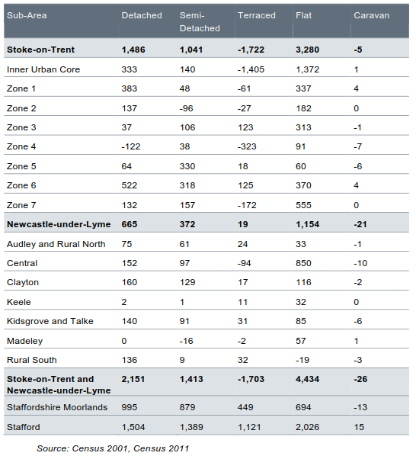
Source: Census 2001 and 2011
- These findings should however, be treated with some caution; the SHMA authors note that the spatial distribution of households registering in need may be shaped by the existing stock, with people in rural areas – or areas with little social housing (of which Keele is an example) potentially less likely to register on the waiting list. Equally, areas with a sizeable social rented stock will meet needs from a wider area, not just those arising from its own neighbourhood.
- It is also worth pointing out that PRS plays a significant role in meeting housing needs in NuL, providing for around 80 households claiming Local Housing Allowance (LHA) each year. The increase in PRS in Keele indicates this is likely to be true for the NP area. Moreover, according to local agents, this picture of apparent balance is likely to be explained in part by lack of availability of stock, with people unable to find suitable housing in Keele forced to look elsewhere.
- While it is outside the scope of this study to consider factors that restrict development, it has been suggested that the widespread application of Green Belt policy in the Parish not only constrains supply of new housing but increases the value of existing properties as a result of the perception of status this confers upon them, therefore effectively deterring some groups.
- Bringing together evidence of current stock and recent supply, there has been a sharp increase in PRS, and this is likely to act as a substitute for Affordable Housing. The apparent equilibrium in the local housing market observed, for example through the lack concealed households, may be an illusion; the lack of available homes (exacerbated by weak supply in recent years) may simply result in a displacement of demand to other surrounding areas. Were this to continue, this could result in polarised population with older residents and students attending Keele University. The absence of any AH waiting list in Keele may be explained by AH tending to concentrate in more urban locations.
- Affordability
- The SHMA notes that historically, the issue of affordability has been less of a concern in NuL than in the surrounding authorities of Staffordshire, Moorlands and Stafford, and overall in England. Nevertheless, affordability has worsened since 1997, with market entry properties in 2013 being 5.2 times lower quartile earnings in Newcastle-under-Lyme.
- In Keele, the mean household income in 2014 was £46,509; this is the second highest of all the sub-areas in the HMA and significantly higher than the local authority average (£34,387), the regional average (£35,611) and the England average (£36,764).
- In Figure 4 below we reproduce Figure 6.8 from the SHMA Appendix 6 showing an income of £22,800 is needed to access private rented accommodation in the Parish. By way of comparison, a similar income could afford to purchase an entry level home in a number of the other sub-areas.
- When looking at the proportion of households able to access housing in their sub-area, 55.4% of households in Keele could afford to purchase an entry level home (AMH), rising to 70% who could afford to rent a 2-bedroom dwelling, and 85.8% who could afford to socially rent a 2 bedroom dwelling. This may have implications for the Parish Council’s attitude to starter homes.

Figure 4: Household Income required to Access Housing in Stoke-on-Trent and Newcastle-under-Lyme
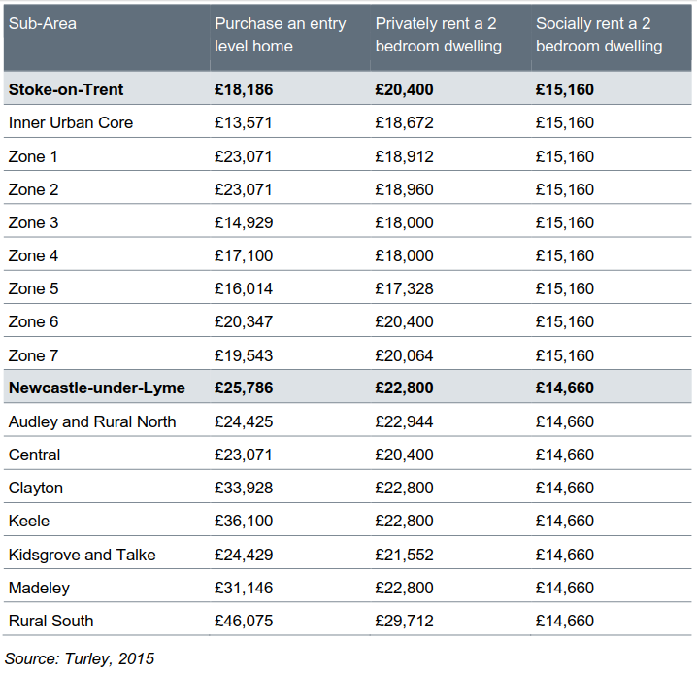
Affordability Ratio
- As we noted earlier, average income in 2014 in Keele is one of the highest in the region, at £46,509. The mean value of property transactions during September 2013 – August 2014 was £174,630. The affordability ratio is therefore 3.75; this reinforces the impression that, for many people, market housing is within their reach. It is important to note, however, that these figures conceal affordability issues for those on incomes lower than the mean.
- A clearer measure of affordability among lower income groups would be to divide the value of entry level properties by Lower Quartile Earnings. This data is supplied by the SHMAU at the district level; below we reproduce Figure 3.2 from this document as Figure 5. This shows that, across NuL as a whole, AMH is out of reach of many households (based on the assumption that a multiple of 3.5 times income may be used to calculate the maximum level of mortgage finance available to a given household).

Figure 5: Lower Quartile Affordability Ratio 2013 – 2015
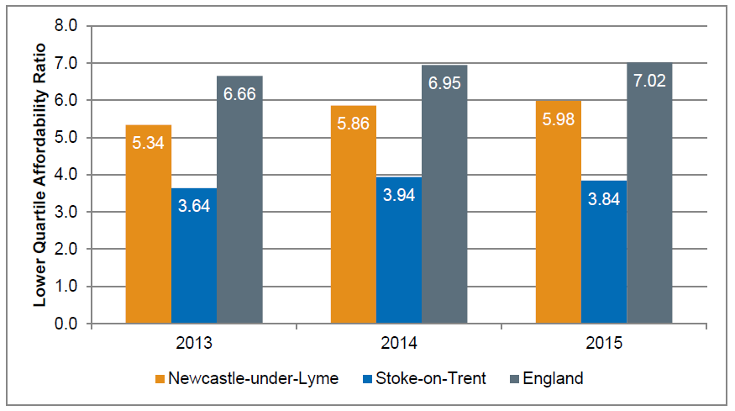
Source: DCLG

Waiting list data
- Current waiting list data, together with the backlog of affordable housing provision, provides an indication of whether current provision satisfies need for affordable housing.
Local housing waiting list (NuLBC, April 2015)
- We requested data from NuL’s Housing Strategy team, for an assessment of the number of households currently on the waiting list that have expressed a preference for being located in the NP area. This provides a useful indication of whether the JCSS’s affordable housing target of 1200 homes across the local authority area is sufficient to meet present affordable need within the plan period.
- The waiting list is divided into seven bands according to urgency of need. Council officers advised that bands 1- 6 were categorised as priority need, whilst band 7 is categorised as being of least urgent need. Therefore we have taken the approach that band 7 should be discounted from calculations of immediate housing need, as households in these categories tend to be on the waiting list more as an insurance policy against future need, rather than in immediate or urgent need. This is standard practice in housing needs assessments and follows the allocation policy adopted by the Council (and in the SHMA). It is noted that one of the entries in Band 7 represents a single adult who would wish to form their own household but cannot currently do so, and is currently housed by family or friends. Such households can be considered ‘concealed households’. Concealed households are captured by census data and are considered as a separate data source elsewhere in this report. We have discounted this household in order to ensure that we do not ‘double-count’. Following this discount there are at present 2 households across the remaining 6 categories in the NP area.
- Although the waiting list is only a snapshot in time, it does seem apparent that, with only 2 households in immediate need of affordable housing, the JCSS policy of 25% affordable housing provision on development sites of over five units in the rural areas should be adequate to meet affordable need over the remainder of the plan period, even allowing for any future increase in affordable need. As such, on the basis of this evidence, there does not appear to be a requirement for the Neighbourhood Plan to set its own affordable housing target, although it may reference the waiting list and mention the need to work closely with NuL Council to ensure the needs of those on the housing waiting list continue to be met.
- It is important to note that even after the Neighbourhood Plan is adopted, the JCSS’s affordable housing policy will continue to apply until such time as the JLP is prepared, and it will still be the Council that will control the housing waiting list and negotiate affordable housing commitments with developers as part of the development management process.
- Considering affordable need at the NP level
- As identified above, the Adopted JCSS sets an affordable housing target of 1,200 dwellings in NuL, broken down into a specified mix of 60% Social Rented, 40% Intermediate. If the NP area had been expected to take a proportionate share of this target, based on its percentage of total dwellings in NuL at the 2011 census (0.812%), this would indicate that roughly 10 affordable units should be delivered during the JCSS plan period (2006-2026), or 0.5 units per year (based on a plan period of 20 years). To put this into context, just 1 new dwelling was completed in the period between 1st April 2011 and 31st September 2015.
- In terms of overall need at the local authority level, the SHMA indicates that NuL has a net need for 163 affordable homes per annum over the next five years, in order to clear the existing backlog and meet future newly arising household need. Once the backlog is cleared, only newly arising need will need to be met, requiring 103 affordable units annually for the remainder of the plan period.
- If the starting point of this requirement is taken from 1st January 2016 and ends on the 31st December 2033, this equates to 5 x163 = 815 affordable dwellings in the first five years (2016-2020), plus 103 x 13 = 1339 affordable dwellings for the remaining plan period (2021-2033) or a total of 2,154. This requirement is a lot higher than the target in the Adopted JCSS (1200), although it is acknowledged that the time periods (i.e. economic conditions) are very different, and that the SHMA represents an unconstrained assessment of need, rather than a constraint-derived target from a policy document.
- If the NP area was to deliver a proportionate element of this total based on its percentage of total dwellings in NuL at the 2011 census (0.812%), this would indicate a requirement for roughly 17 affordable units to be delivered between 2013-2033 in the NP area. It is important to note this figure represents an unconstrained assessment, and that the various supply side considerations would need to be factored into a final target, if the NP were to adopt one.
- SHMA – projected affordable housing need
- The SHMA sets out an approach for calculating current and future affordable housing need; this involves calculating the number of households currently classified as in need of affordable housing and subtracting from this the number of affordable housing units available. The calculation for future need is obtained by calculating the new households likely to form each year who will be unable to afford market housing and deducting this from affordable housing supply, an estimate based on all lettings from all Housing Register Bands over the last three years. Figure 6 reproduces SHMA figure 7.3 shows this calculation in summary form. These figures re-state the position derived from waiting list data that there is little additional requirement for affordable housing in Keele.
Figure 6: Affordable Housing Need by Sub-Area – Newcastle-under-Lyme
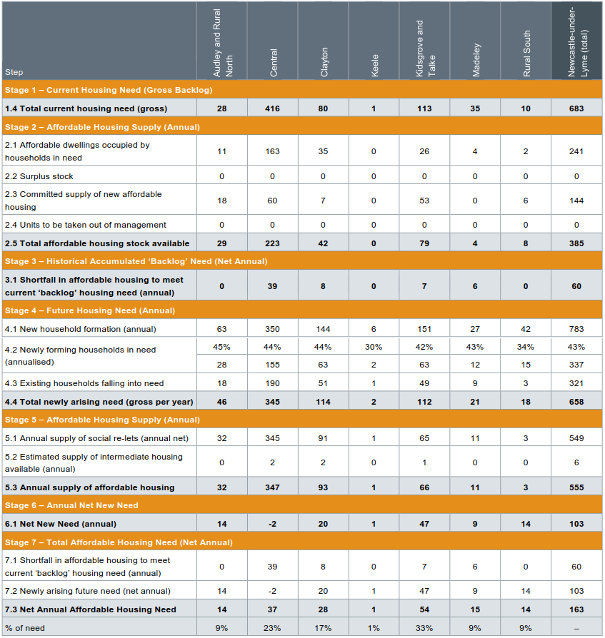

- Bringing together our understanding of affordability, for those on mean incomes, AMH is within their reach; those on lower incomes will however struggle to afford market housing, leading to a position in which their needs must be addressed through some form of subsidised housing. Notwithstanding, Housing Waiting List data suggests very little need for AH emanating from the Parish, certainly an insufficient quantity to justify the NPA setting a AH policy that departs from that which appears in the currently adopted Local Plan. Based on a 'fair share' calculation however, the NPA may seek to delivery 17 dwellings over the Plan Period.
- In the next section we briefly consider how housing need may be addressed through both affordable and market housing.
- Affordable Housing
- The SHMAU provides helpful update on definitions of AH and how this is likely to change following the Government’s Housing White Paper in February 2017. We quote these paragraphs in full.
- The Passage of the Planning and Housing Act 2016 coincided with consultation by Government on proposed changes to national planning policy, which made clear its commitment to home ownership but recognised the important role of affordable rent for those not currently seeking home ownership. The changes proposed would broaden the definition of affordable housing, supporting ‘present and future innovation by housing providers in meeting the needs of a wide range of households who are unable to access market housing’. This would include ‘products that are analogous to low cost market housing or intermediate rent, such as discount market sales or innovative rent to buy housing. Some of these products may not be subject to ‘in perpetuity’ restrictions or have recycled subsidy’.
- The Housing and Planning Act made provision for a new simplified definition of affordable housing as ‘new dwellings…to be made available for people whose needs are not adequately served by the commercial housing market’. Secondary legislation is required to implement this definition, necessitating further parliamentary debate.
- The Government’s recently published Housing White Paper confirms that a revised definition will be brought forward through changes to the NPPF later this year, proposing a definition of affordable housing as ‘housing that is provided for sale or rent to those whose needs are not met by the market (this can include housing that provides a subsidised route to home ownership’ and which ‘meets the criteria’ for one of the following models:
• Social rented housing, defined as currently and owned by local authorities and private registered providers with guideline target rents determined through the national rent regime. It may be owned by other persons and provided under equivalent rental arrangements, as agreed with the local authority or Homes and Communities Agency;
• Affordable rented housing, defined as currently and let by local authorities or private registered providers of social housing to households eligible for social rented housing. Affordable rent is controlled at no more than 80% of the local market rent including service charges where applicable;
• Starter Homes, as defined in the Housing and Planning Act 2016 and subsequent secondary legislation with an income restriction of £80,000 outside London. These homes are expected to provide a new low cost market housing product for first time buyers between the ages of 23 and 40 with a mortgage, sold for no more than 80% of open market value and capped at £250,000 outside London;
• Discounted market sales housing, sold at a discount of at least 20% below market value with provision to remain at a discount for future eligible households. Eligibility is to be determined with regard to local incomes and house prices;
• Affordable private rent housing, made available for rent at a level which is at least 20% below local market rent with provision to ensure that rent remains at a discounted level or alternative affordable housing provision is made if the discount is withdrawn. This is viewed as particularly suited to the provision of affordable housing in Build to Rent schemes; and
• Intermediate housing, defined to include discounted market sales and affordable private rent housing – as outlined above – and other housing that is ‘provided for sale and rent at a cost above social rent, but below market levels’.
- A transition period is proposed to enable a review of local policies, with the revised definitions intended to apply from April 2018. The Government also intends to introduce a requirement for sites of 10 units or more to ensure that at least 10% of all homes are affordable home ownership products, including Starter Homes, shared ownership homes and homes available for discount market sale.
- While it is outside the scope of this study to go into detail as to how AH should be apportioned to the different types, the adopted policy of the LPA should be used as a starting point. Current policy reads as follows: The type and tenure of this affordable provision will be determined on a site by site basis to reflect specific local needs. However, in order to create genuinely sustainable mixed communities, an appropriate mix of social rented and intermediate affordable housing will need to be delivered.
- The broad target for the overall mix of affordable housing to be delivered within NuL is split between social rented and intermediate dwellings of 60% and 40% respectively.
- Bearing in mind the reforms to the definition of AH expressed in the Housing White Paper however, on the basis of the evidence we have gathered (that indicates an increase in PRS as well as an increasing AR that suggests AMH may outstrip households incomes in years to come), we would recommend both discounted market sales housing and affordable private rent housing form part of the AH quota within the NPA, with policy seeking to fulfill the 10% policy expectation for Starter Homes.
- We note that 20% is a minimum discount and, of course, greater discounts will make the policy more effective in enabling households on modest incomes afford to buy their own home. The ultimate level of discount should be arrived at on a site-by-site basis and will be determined by viability as well as other calls on finite resources stemming from planning gain, such as other forms of AH and infrastructure requirements.
- While the Housing White Paper does not specify size of development, it is appropriate for this to be taken into account when considering how the 10% policy expectation should be applied in practice. When the policy was conceived, it was linked to the notion of rural exception sites, land that would normally not be considered for housing, to bring forward substantial numbers of affordable dwellings where there is evidence of local need.

- It is important to note affordable housing policy only applies to schemes of 10 units or above unless robust evidence can be put forward of housing need in the local area. Therefore, in the absence of relatively substantial schemes coming forward, given the relatively modest levels of additional housing our house projections envisage, this issue may not apply to Keele.
- Market Housing
- Given the limited quantity of Affordable Housing in the NPA, the needs of the great majority of the people will be served by the market. People on higher incomes will be able to access a variety of market dwellings; their choices will be driven principally by how much they can afford to spend, the extent to which old age is driving their choice of home as well as personal taste.
- The operation of the market is the best means of addressing the demand for different types of housing for sale. It is important planning policy does not place unnecessary burdens on the market preventing its ability to respond to demand; this is after all the principal way equilibrium is achieved in the housing market and house price growth kept in check. In this way, the notion of viability is essential. It is important not to deter development in the context of clear housing need; to do so will not only frustrate the delivery of new housing but also may deprive the community of resources for infrastructure improvements.
- Planning policy has a vital role of bringing about change in the profile of housing stock over time where there is evidence of a misalignment between demand and supply that the market is unlikely to correct without intervention. The needs of those unable to access market housing without subsidy is one example. Others concerns are, firstly, that build to rent (BTR) will be held back as a result of for-sale developments generating higher land values, allowing developers to make higher bids for land; and, secondly, long term demographic shifts that foresee a dramatic growth of a household type with specific needs (for example those suited to older people) that impose greater costs on development therefore pushing development in the direction of other types and sizes of dwellings that yield a greater return.

Type
- Keele has a preponderance of detached and semi-detached properties, together representing 64.8% of total stock; 20.4% of the housing stock are flats, and the remainder (13.9%) are terraced houses. In table 8 below we set out the size of dwellings, measured by number of rooms, in the NPA. From this table, the dominance of larger dwellings in the area is apparent; of all homes in 2011, 55% were sized 6 bedrooms or more; this is the equivalent of a four bedroom house, whereas only 26% were of 3 and 4 rooms, an entry level home suitable for a young family.
Table 7: Number of rooms per household in Keele, 2001 and 2011
 | 2001 | 2001 | 2011 | 2011
Number of Rooms | Keele | NuL | Keele | NuL
1 Room | 0 | 157 | 1 | 94
2 Rooms | 4 | 674 | 2 | 654
3 Rooms | 26 | 3585 | 25 | 4282
4 Rooms | 44 | 9577 | 80 | 9004
5 Rooms | 75 | 16129 | 78 | 14879
6 Rooms | 74 | 11511 | 62 | 11948
7 Rooms | 37 | 4286 | 56 | 5408
8 Rooms or more | 101 | 4819 | 45 | 3321
9 Rooms or more |  |  | 60 | 2984
Source: Census 2001 and 2011, AECOM Calculations

- In order to understand whether this is suited to community needs in future years as well as today, it is helpful to identify different ‘market segments’ within the population. These can be determined through a consideration of the age structure, and how this has changed over time, together with household composition.
- Age Structure
- In considering the age structure of the Parish, the high proportion of residents aged 16-24 is immediately apparent. Many of these individuals will be students at Keele University and, while a significant proportion of students will be catered for directly by the university in the form of purpose designed student accommodation, their presence is a relevant topic for the HNA to address. This is looked at more closely in the ‘Specialist Housing’ section to follow.

Figure 7: Age Structure

Source: ONS, 2011. AECOM calculations

- While it is right that the needs of students should be taken into consideration, their needs are first and foremost the responsibility of the University. So as to understand housing needs as it relates to the area’s permanent population, KPC has helpfully provided data which removes the non-permanent student population from the area (defined as residents living in University undergraduate accommodation) while retaining postgraduates and staff residents in the parish. This is set out in Figure 8 below. Contrary to the Figure 7 above, this indicates an age structure more closely aligned with that of NuL. The 25-44 and 45-64 age groups constitute roughly 28% of the population respectively; the 0-15 age group is around 18%, the 16-24 age group around 8% and those aged 65+ of around 17%.

Figure 8: Age Structure
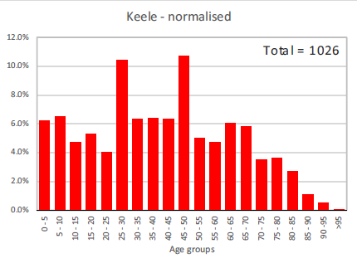.
Source: KPC

- Moreover, the rate of change in the age structure revealed in Census data (see Table 8 below) suggests a decline in the numbers of people falling into the age group most likely to start families (the fall in the proportion of the population in the 25-44 age bracket between 2001 and 2011 is 8.1%); this data is reinforced by the SMHA that identifies outflows of people aged between 20 and 29. While this is explained in part by the need among many to move out of the area to access graduate-level employment, demand displacement is also likely to be a factor. Indeed, economic data suggests the NP area remains an attractive place for people to live and work, with job opportunities available at the University as well as within the wider ‘functional economic area’ of Newcastle-under-Lyme and Stoke-on-Trent. This is considered in more detail in the Employment Trends below.
Table 8: Rate of change in the age structure of the population of Keele, 2001-2011
Age group | Keele | Newcastle-under-Lyme | England
0-15 | 26.9% | -7.3% | 1.2%
16-24 | 14.4% | 13.6% | 17.2%
25-44 | -8.1% | -9.5% | 1.4%
45-64 | 11.9% | 9.2% | 15.2%
65-84 | 18.2% | 6.8% | 9.1%
85 and over | 13.3% | 28.3% | 23.7%
Source: ONS, Census 2001 and 2011. AECOM calculations

- Below we reproduce Table 4.1 from the SHMAU as Table 9; this is helpful in identifying the possible change in the age structure in future years. The SHMAU considers three scenarios for assessing demographic change; as Table 9 below shows, all three forecast a very substantial increase in numbers of those aged 65 and over in the NPA.

Table 9: Projected Demographic Population Change by Age 2013 – 2039
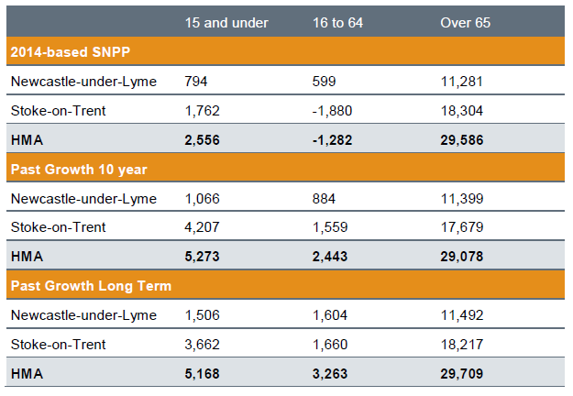
Source: ONS, Edge Analytics

- There is compelling evidence that young people in employment looking for housing in the region would buy property in Keele if there was a greater availability of suitable stock. The absence of these people, indeed their continual drain from the area, threatens to undermine the vitality and viability of the existing community. This finding chimes with a view expressed by KPC.
- ‘the least accommodated for group currently in Keele Village are young career academics - we are talking about people between the ages of around 24-34 who are have had no time to save for a significant deposit due to their studies but may be in a position to begin saving now they are earning as reasonable wage (this also includes young administrators, and young non-academics working at Keele)’.
- For this group, relatively little suitable housing has been provided in recent years, and none over the period 2011-15. Indeed, the overall proportion housing in the area suited to the needs and pocket of people falling into this segment of the housing market, terraced housing, accounts for just 13.9%; this compares with 20% for Newcastle-under-Lyme and 30% for Stoke-on-Trent. As identified earlier, only 11 properties of this type were built between 2001 and 2011.
- In usual circumstances, this would give rise to ‘concealed families’, those living with other households in the same dwelling, or overcrowding, where families are forced to live in smaller accommodation than is deemed appropriate. The fact this isn’t happening supports reported evidence from the community, that people working locally tend to live ‘away from Keele’ and commute in, a phenomenon that exacerbates traffic congestion issues, a concerned voiced repeatedly by members of the community during consultation events.
- The SHMAU includes an important qualification as to how future housing provision should be planned; it identifies a very real danger that by not specifically planning to provide dwellings for younger households, this group will be excluded from the labour market, impacting on the vitality of settlements across the district and weakening the labour market, thus undermining the prospects for economic growth.
- To overcome this problem, it recommends adjustments to the 2014 Sub-National Population Projections, envisaging ‘a return to the higher levels of household formation’ seen in 2001. Below we reproduce Table 2.6 from the SHMAU as Table 8 that sets out the impact of this adjustment.
Table9: Impact of Headship Rate Return Sensitivity (dwellings per annum 2013 – 2039)
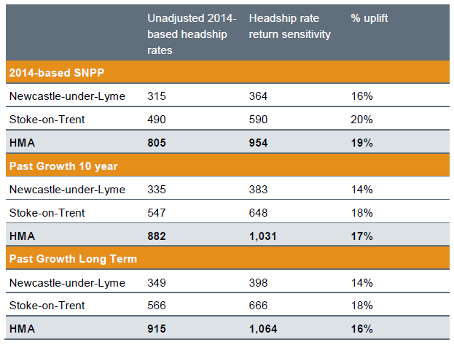
Source: Edge Analytics

- The following extract from the SHMAU is helpful. This adjustment uplifts the implied number of homes needed to support the growth in population projected under each scenario, as a direct result of the additional younger households assumed to form. Over the assessment period, this adjustment allows for the formation of approximately 3,700 younger households across the HMA who would otherwise be unable to form if the unadjusted 2014-based headship rates were applied.

- The SHMAU concludes that, in arriving at the Objectively Assessed Need for Housing, applying the improved household formation rates to a longer term trend-based demographic projection is considered the most appropriate demographic scenario for the future growth of Stoke-on-Trent and Newcastle-under-Lyme.
- Bringing the evidence relating to age structure together, this suggests broad similarities with the wider district, indicating forecast demographic change set out in the SHMAU will be similar between the two geographies. The shrinking share of the population accounted for by those aged 25-44 should be a cause for concern, as this, if it continues, threatens the vitality and viability of the settlement. In addition, the increasing numbers of the elderly creates an obligation to provide housing suited to their needs.
- Household composition
- Table 9 sets out how the area was composed in terms of households in 2011; this shows a balance corresponding broadly with the borough and England as a whole. It is worth noting, however, that table 9 also shows a significant minority of people living alone (36% compared with Newcastle-under-Lyme of 31%).

Table 10: Household composition (by household) in Keele, 2011
Household type
 |  | Keele | Newcastle-under-Lyme | England
One person household | Total | 36.4% | 30.9% | 30.2%
One person household | Aged 65 and over | 9.5% | 13.5% | 12.4%
One person household | Other | 26.9% | 17.3% | 17.9%
One family Household | Total | 58.9% | 63.9% | 61.8%
One family Household | All aged 65 and over | 10.8% | 9.3% | 8.1%
One family Household | With no children | 15.6% | 18.5% | 17.6%
One family Household | With dependent children | 25.4% | 25.4% | 26.5%
One family Household | All children non-dependent | 7.1% | 10.7% | 9.6%
Other household types | Total | 4.6% | 5.2% | 8.0%
Source: ONS, Census 2011. AECOM calculations

- Table 11 offers a longitudinal assessment of Household Composition, showing a marked swing, between 2001 and 2011, towards solo households, and within this group, a modest drop in the proportion of people over the age of 65.
Table 11: Rates of change household composition in Keele, 2001-2011
Household type |  | Percentage change, 2001-2011
 |  | Keele | Newcastle-under-Lyme | England
One person household | Total | 36.7% | 12.3% | 8.4%
One person household | Aged 65 and over | -7.1% | -8.2% | -7.3%
One person household | Other | 64.2% | 36.0% | 22.7%
One family only | Total | 5.7% | -1.5% | 5.4%
One family only | All aged 65 and over | 2.3% | -2.2% | -2.0%
One family only | With no children | -8.6% | 0.3% | 7.1%
One family only | With dependent children | 19.5% | -4.5% | 5.0%
One family only | All children non-dependent | 3.6% | 3.7% | 10.6%
Other household types | Total | -26.9% | 26.5% | 28.9%
Source: ONS, Census 2001 and 2011. AECOM calculations

- Below we reproduce SHMAU Figure 7.1 as Figure 9; this suggests the finding in Table 11 of a trend towards solo households will remain true over the longer term. It also forecasts that NuL is projected to see a sizable growth in the number of families without children and households with dependent children.

Figure 9: Change in Household Profile (Supporting Likely Job Growth) 2013–39
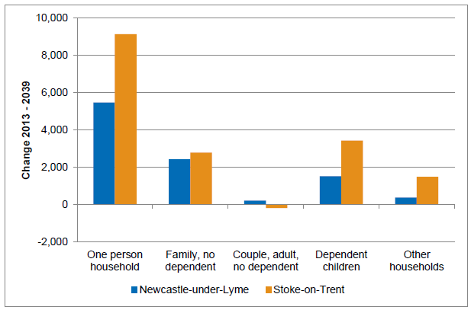
Source: Edge Analytics

- Bringing the evidence related to household composition together, the NPA is forecast to see an increase in solo households, and it is unlikely to escape the trend, seen across the country as well as at the borough level, of an increase in smaller family and solo household of occupants aged 65 and above.
- As we have seen, larger detached and semi-detached dwellings account for around 65% of all types. While there is an apparent abundance of larger properties, new provision in recent years has been very limited, leading to a concern that as people seek to move to larger homes (on account of the growth of families and income) they are unable to do so, again forcing them to move away from Keele.
- The SHMA observes that the inability to retain higher-paid individuals is damaging the local economy, and threatens to bring about an imbalance within the local demographic profile. Moreover, Census data suggests that the issue of under-crowding is getting worse in Keele; Table 11 shows the proportion of dwellings with 1.5 people or more per room decreased between 2001 and 2011 by 83%.
- Building more homes suited to the needs of people who wish to down-size would be a way to enable older people who do not wish to move out of the village to remain, while freeing up larger properties for younger people, addressing both these issues at the same time. Table 12 shows the extent to which the number of people in a dwelling decreased substantially between the 2001 and 2011 Censuses; this corresponds with older, shrinking households staying in the family home.
Table 12: Trends in number of persons per room in Keele, 2001-2011
Persons per room | Keele | Newcastle-under-Lyme | England
Up to 0.5 persons per room | 10.8% | 7.5% | 7.9%
Over 0.5 and up to 1.0 persons per room | 21.8% | -6.6% | 7.0%
Over 1.0 and up to 1.5 persons per room | -33.3% | -5.1% | 27.3%
Over 1.5 persons per room | -83.3% | -34.3% | 2.5%
Source: ONS, Census 2001 and 2011. AECOM calculations

- In the earlier section looking at tenure we noted that the evidence points to making those early in their careers, falling into the 25-44 age bracket, a priority for housing policy Keele. The SHMA points to similar findings at the local authority level, suggesting that there is a net short-fall of properties of all sizes, with the exception of larger properties of four bedrooms or more. The SHMAU suggests that, at the district level, modeling indicates that the greatest demand for housing in each authority is for properties with two or three bedrooms, with the types of household that typically occupy dwellings of this size (families) projected to increase. We reproduce the relevant Table (7.2) as Table 13 below.
Table 13: Implied Size of Housing Required (Supporting Likely Job Growth) 2013 – 2039
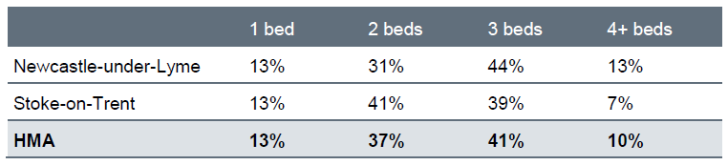
Source: Turley; Edge Analytics; Census 2011

Specialist housing
- The housing market in Keele is strongly influenced by the presence of the University; this institution is a key driver of economic activity, providing employment and attracting a large number of students. Furthermore, as noted above, Keele University’s Strategic Plan 2015-2020, sets out plans to expand the student body by 3,000 in coming years.
- The University has indicated that around one third of this growth will be accommodated on campus, with off-campus provision required to house the remaining additional student population. Indicatively, based on the growth to around 13,000 students, this would suggest that an additional 2,000 students may require accommodation off-campus. The SHMA notes there is likely to be a gap between the number of students requiring accommodation and the number of student bed-spaces in Newcastle-under-Lyme.
- As has been observed by KPC, it is possible therefore that HMOs in particular will play a role as a mechanism for relieving demand for student accommodation where there is an imbalance between supply of student accommodation and demand. Indeed, the SMHA notes there are 646 student Council Tax exemptions recorded in Newcastle-under-Lyme – predominantly in the Keele and Central sub-areas – a label which can indicate an HMO. It is also worth reiterating that local agents describe the rental market as dominated by demand for student homes.
Figure 10: Student Accommodation by Type 2011
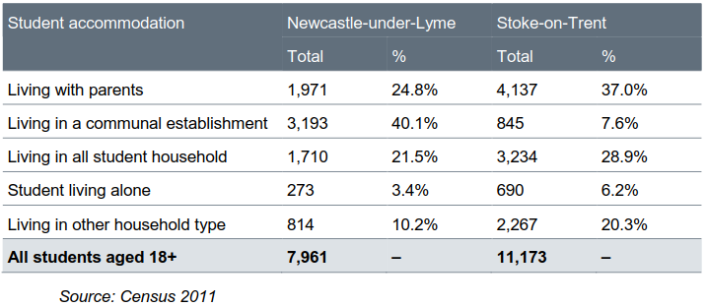
Source: Census 2011

- Data from the SHMA notes that 21.5%, or 1710, of all students live in ‘all student households.’ For the purposes of this HNA, an assumption can be made that of the 3000 additional students, the same proportion will live, by their own choice or otherwise, in a household shared exclusively with other students. This equates to 645 individuals.

- The question therefore arises as to what proportion (if any) of these people will live in or want to live in the Parish and compete with others for limited housing supply. Notwithstanding remarks about the rental market, local agents suggest that most students prefer to live in central Newcastle-under-Lyme, close to its shops and amenities. The SHMA itself notes that students are distributed widely across the region (student household exist between a 6 to 10 mile radius of the University) – with particular concentrations in Silverdale and Stoke-on-Trent. Indeed, the map of student exemptions mentioned earlier suggests a distribution across the local authority area (although this map does not distinguish between households of Keele students and those of Staffordshire University).
- Therefore, despite the arrival of significant numbers of additional students we do not foresee their having a great bearing on housing need in the NP area. Local agents were in agreement, citing not only student tastes, but also the delivery of three speculatively built student blocks in central NuL.
- Having said this, the increase in employment opportunities to service this expanded student body may well increase the pressure for non-student housing; this is discussed further in the Economic development section to follow.
Figure 11: Distribution of Student Exemptions
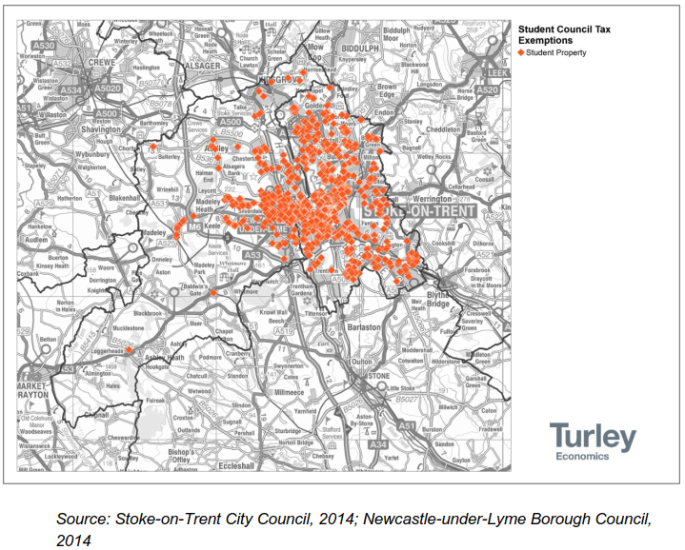

- Bringing the evidence together on student housing, while there is an estimated need to house around 650 students 'off campus', given the wide distribution of student households across the district, and the preference of undergraduates in particular to live close to urban centres, we see the impact of this growth as being limited to the extent that no specific provision for students is required within this HNA.

Market Signals
- The PPG highlights the importance of taking ‘market signals’ into account when assessing housing need, given they provide an indication of the balance between demand and supply. This is particularly important to consider given the significant and well-documented changes in the housing market over recent years, which were exacerbated by the economic downturn and subsequent issues in obtaining mortgage finance.
- These market signals relate to trends, including higher than average house price rises, discernable within the housing market, and broader economic trends that have an impact on the housing market.
- The PPG goes on to assert that where there is evidence of an imbalance in supply and demand, an uplift in planned housing numbers – compared to those derived solely from household projections – is required in order to increase the supply of housing to meet demand and tackle affordability issues.
- As we have seen, there is compelling evidence for an inadequacy of supply, expressed in higher prices for homes and in the movement of people away from the area. A further associated cost is the strain imposed on the transport network by people working at the university, but who have to commute in on account of the lack of suitable housing in Keele village.
- Housing market
House prices
- SHMA figure 5.5, and reproduced below as Figure 12 shows mean house prices according to different property types in 2013/14 across the various sub-areas in Stoke-on-Trent and Newcastle-under-Lyme. This shows that across all types, Keele is the most expensive area in the region after the Rural South. These relationships are displayed graphically in Figure 3.8 from Appendix 3 of the SHMA.

Figure 12: Mean Price paid by Housing Type 2013/14
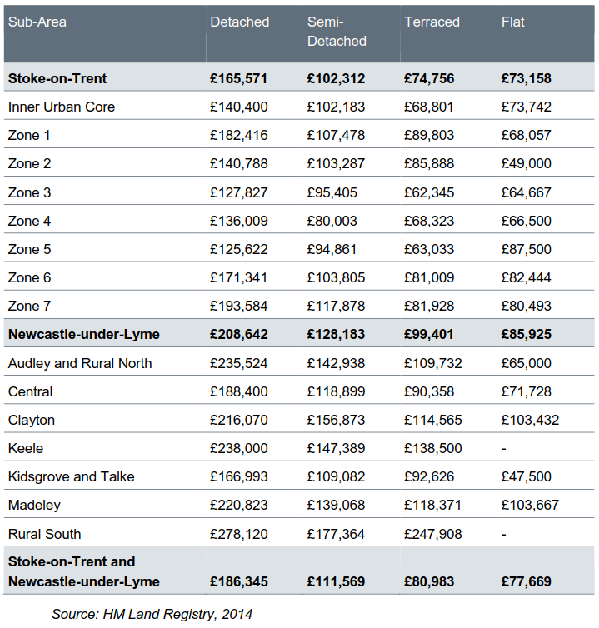

- The only exception to this are semi-detached properties in Clayton which fetch higher prices, and this flows through into the median house price by sub-area (shown below in Figure 13, which re-produces SHMA table 5.4) which shows Keele ranked third.

Figure 13: Median House Price by Sub-Area 2013/14
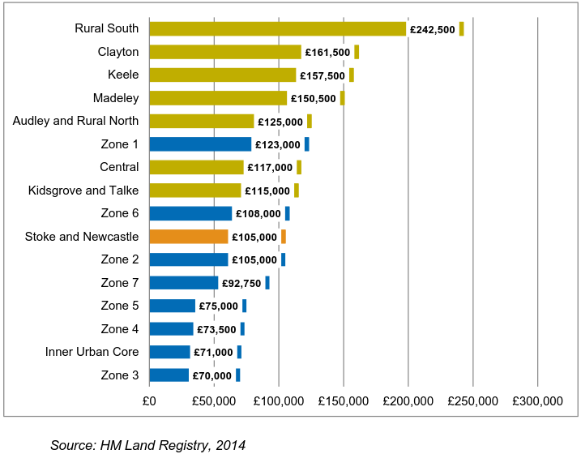
- Below we reproduce SHMAU Table 3.1 as Figure 14; this shows how house prices at the district level have altered between 2001 and 2015 for two price points: the mean and lower quartile. Mean prices over the period have increased by an average of 8.4% each year. Lower quartile dwellings on the other hand have shown a stronger appreciation, achieving roughly 10.5% each year.
Table 14: Change in Lower Quartile and Mean House Prices 2001-2015
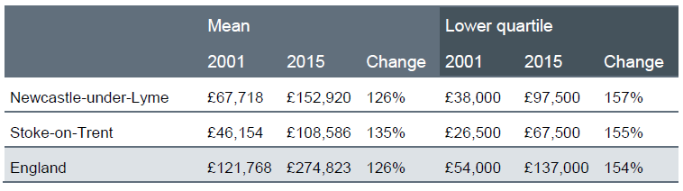
Source: Land Registry

- Volume of transactions
- SHMA Figure 5.9 (reproduced below as Figure 15) demonstrates that a very low volume of transactions took place in Keele during 2013/14; this indicates both the limited size of the market, but also the lack of availability. This is reinforced by feedback from local agents who report that very little has come to market since 2014.
Figure 15: Volume of Transactions by Property Type 2013/14
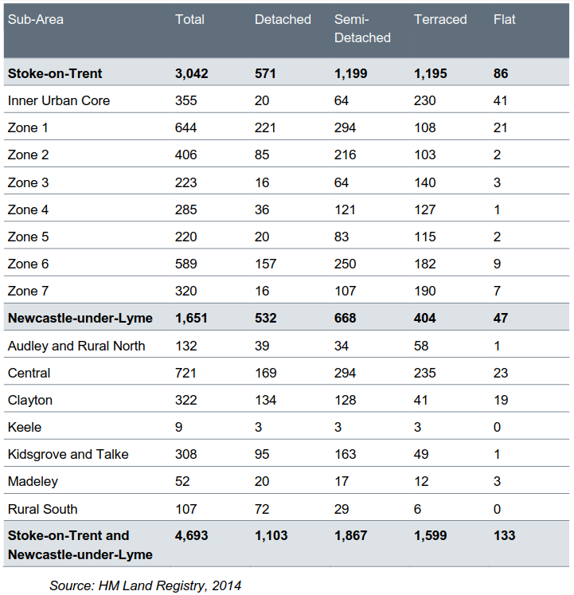

- Rate of development
- SHMA Figure 5.17 (reproduced below as Figure 16) shows the net dwelling completions for the region from 2000/1 – 2013/14. As reported previously, 44 new dwellings were delivered in Keele parish between 2001 and 2011, of which 36 of these were brought forward by the University at one site, Horwood Hall. To update figure 5.17, the number of completions from 1st April 2014 and 30th September 2015 within NuL was 311.
- Data supplied by the LPA indicates that only 1 new dwelling was delivered in Keele between 2011 and 2015.
Figure 16: Net Dwelling Completions 2000/01 – 2013/14
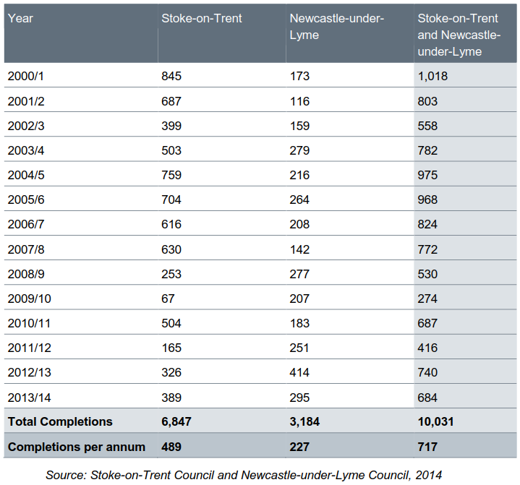

- Overcrowding

- 1.1% of households in Keele were overcrowded at the 2011 Census, compared to 2.7% in NuL, 3.8% across the HMA, and 4.6% in England. This is relevant as low rates of over-crowding are an indication of weak demand for housing. At the other end of the scale, 77.4% of households in Keele were under-occupied, compared with 73.3% in NuL, 69.0% across the HMA and 68.7% in England.
- Rather than treating this as evidence of weak demand, it is more likely to arise as a result of a reluctance on the part of established residents to move from the area (for older people that may have to do not only with the area’s natural beauty, but also the family and friendship ties that exist there), but also that lack of available stock to facilitate downsizing.
- Vacant dwellings
- The data in the SHMA is taken from Council tax data, as the most reliable indicator of the number of unoccupied properties. In August 2014, a total of 1,401 properties in NuL were vacant, of these, 366 had been empty for more than two years, suggesting an overall vacancy rate of 2.5%, with 0.7% of the total housing stock vacant for over 2 years. At the regional and national level the overall vacancy rate in 2013 was 2.7%, a comparable figure is not available for long-term vacancy.
- In August 2014 Keele contained just 1.1% of all vacant dwellings in the local authority area; it also accounted for only 1.1% of all long-term vacant properties (empty for more than two years). By way of contrast, the central sub-area of NuL contained 51.7% of all vacant dwellings and 46.7% of long-term vacancies. Figure 17, which reproduces SHMA figure 3.8, shows the percentage of homes empty by sub-area.
Figure 17: Percentage of Empty Homes by Postcode Area
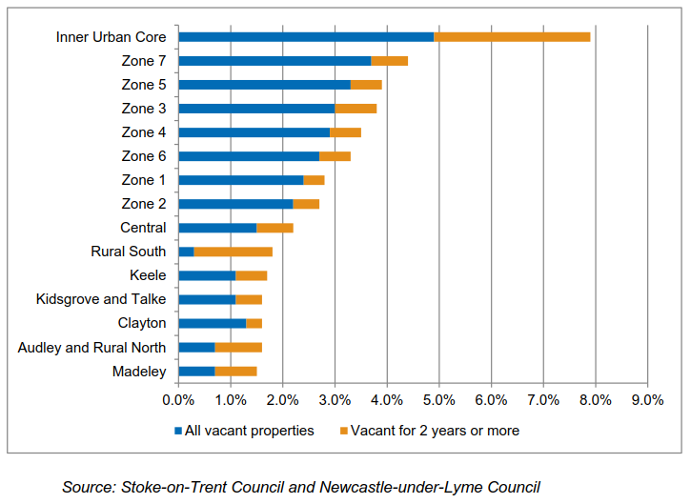

- Employment Trends

- The PPG states that a HNA should take employment trends into account. This is to ensure that any conclusions on housing need allow for the likely change in job numbers based on past trends or economic forecasts as appropriate and also have regard to the growth of the working age population in the housing market area. In this case, we have taken into account the relevant Employment Land Review and Strategic Economic Plan; in doing this we have also considered significant proposed developments which we believe may have an impact on future employment in the area. Table 15 below, provides an indication of the current economic activity.

Table 15: Economic activity in Keele, 2011
Economic category |  | Keele |  | NuL |  | England
 |  | As % | No. of persons | As % | No. of persons | As %
Economically active | Total | 31.8% | 1230 | 66.7% | 92,335 | 69.9%
Economically active | Employee: Full-time | 8.1% | 314 | 37.8% | 34,876 | 13.7%
Economically active | Employee: Part-time | 2.1% | 80 | 13.8% | 12,736 | 38.6%
Economically active | Self-employed | 1.6% | 62 | 7.6% | 6,987 | 9.8%
Economically active | Unemployed | 0.3% | 11 | 3.7% | 3,378 | 4.4%
Economically active | Full-time student | 19.7% | 763 | 3.9% | 3,591 | 3.4%
Economically inactive | Total | 68.2% | 2635 | 33.3% | 30,767 | 30.1%
Economically inactive | Retired | 2.4% | 93 | 16.1% | 14,830 | 13.7%
Economically inactive | Student | 64.7% | 2501 | 7.6% | 7,063 | 5.8%
Economically inactive | Looking after home or family | 0.6% | 22 | 3.2% | 2,983 | 4.4%
Economically inactive | Long-term sick or disabled | 0.2% | 7 | 4.7% | 4,341 | 4.1%
Economically inactive | Other | 0.3% | 12 | 1.7% | 1,550 | 2.2%
Source: ONS, Census 2001 and 2011. AECOM calculations

- Keele’s proportion of economically active residents is considerably lower than both the local and national levels. However, Keele's unemployment level at 0.3% is lower than the local 3.7% and national 4.4% average. This can be explained by Keele’s high student population which accounts for 64.7% of the economically inactive.

- In addition, while these figures suggest the level of retired people in Keele 2.4%, which is significantly lower than both the local 16.1% and national 13.7% averages, this too is likely to be skewed by the high proportion of students in the data. If we accept KPC calculation of 1026 residents who are permanently resident in the NPA, the proportion of retired people increases to between 9-10%.

Newcastle-under-Lyme and Stoke-on Trent: Joint Employment Land Review (Nathaniel Lichfield & Partners 2015)

- The Joint Employment Land Review 2015 (ELR) represents the Council’s most up-to date assessment of future employment growth. Three employment projections are referenced which forecast employment growth over 2013-2039, the forecast for jobs in Newcastle-under-Lyme range from 6,329 (Oxford Economics), to 9,181 (Experian) and 9,898 (Cambridge Econometrics). Keele has good access links to the rest of Newcastle-under-Lyme and therefore it may be seen as an attractive place to live for those wanting to avail of the increasing employment opportunities.

- Census data as shown below in Table 16) indicates that Keele is already popular with long distance commuters. A significantly high proportion of Keele's workforce 20.5% travel more than 30km to work, this is higher than both the NuL 7.6% and national 8.0% levels. Average distance travelled to work is also higher in Keele at 24.3km compared to the national average of 14.9km and the average for NuL of 14.9km.

- These quantitative findings are supported by feedback from local agents who suggest Keele is an attractive place to live not only for people working at the University and the Royal Stoke Hospital, but also in the wider regional economy on account of easy access to road infrastructure, for example the M6 motorway.

Table 16: Distance to work, 2011
Location | Keele | Newcastle-under-Lyme | England
Less than 10km | 58.0% | 60.3% | 52.3%
10km to less than 30km | 6.5% | 16.5% | 21.0%
30km and over | 20.5% | 7.6% | 8.0%
Work mainly at or from home | 10.3% | 8.7% | 10.3%
Other | 4.7% | 6.9% | 8.5%
Average distance travelled to work | 24.3km | 14.1km | 14.9km
Source: ONS, Census 2001 and 2011. AECOM calculations

- The ELR also makes reference to the Keele University Science and Innovation Park. Adjacent to the established Science Park, 28 hectares of available land has been split into 13 plots for a variety office developments and a proposed hotel use. Innovation Centre 5 (IC5) is the first of these developments and is due for completion in August 2016. Once fully occupied, IC5 could accommodate around 300 jobs. Two additional plots within have been sold subject to contract.

Stoke-on-Trent and Staffordshire Strategic Economic Plan (Stoke-on-Trent & Staffordshire Enterprise Partnership, 2014)

- Keele lies within the Stoke-on-Trent & Staffordshire Enterprise Partnership and is therefore subject to its Strategic Economic Plan (SEP). It should be noted that this is an aspirational document used to bid for funds, and has not been fully tested at examination; the information should be used cautiously. Part 1 of the SEP published in March 2014, sets out the highly ambitious aim of growing the economy by 50%, generating 50,000 new jobs over the decade to 2021.

- The SEP identifies key sectors which sit centre-stage in business growth agenda for the area, two sectors in particular (Medical Technologies and Energy Generation) have a strong connection with Keele. The SEP acknowledges Keele University will play a major role in attracting additional growth in these sectors; with the retention of graduates being particularly important to achieving this. This could result in an increase in housing demand from people aged 25-44 in Keele. This is significant as this age group is the only group which saw a proportional decrease in people between 2001 and 2011. The 25-44 age group would tend to demand family-sized housing, (indicating a need for properties with 3 or more bedrooms).

- University Expansion

Regeneris Report: Economic Impact of Keele University (2016)

- This independent study looked at Keele University’s economic impact, considering the planned growth in student numbers, the expected growth in business engagement and future investments in facilities, accommodation and services. In its future forecasting to 2023, the report highlights the potential for specific investments relating to the University’s to create over 625 high value jobs. This is significant and may be worth exploring this figure more with Keele University as to how many of the people taking up these jobs would prefer to live locally and the type of accommodation they would aspire to.

Keele University Strategic Plan 2015-2020

- This plan talks further about the ambition to attract 3,000 additional students and the desire to grow the international student base. The University has indicated that around one third of this growth will be accommodated on campus; suggesting that an additional 2,000 students may require accommodation off-campus. This will likely generate an increase in demand for private sector accommodation and HMOs.

4 Conclusions

Overview
Table 17 Summary of factors specific to Keele with a potential impact on neighbourhood plan housing quantity
Factor | Source(s) (detailed in Chapter 3) | Possible impact on future housing need | Rationale for judgement
House prices | SHMA, SHMAU | ↑ | Our findings suggest a steady growth in prices, with some evidence that prices are starting to outstrip household income. One upward arrow has therefore been applied to underpin affordability in future years.
Volume of Transactions | Local Agents, Community surveys, SHMA | ↑ | The lack of suitable stock is the principal reason why demand displacement is taking place; in particular young families who would prefer to live in Keele, but who cannot do so on account of dwellings only rarely coming onto the market. For this reason, one ‘up’ arrow has been applied.
Overcrowding | Census | ↔ | Despite the absence of overcrowding (which would normally suggest weak demand) we do not see this as justifying an increase or decrease in the supply of dwellings on account of the existence of other data that suggests this is more likely to do with, firstly, demand displacement and, secondly, the occupation of dwellings by older residents who might downsize, were there the opportunity to do so.
Vacant Dwellings | SHMA | ↑ | The low level of vacant dwellings suggests high demand for housing in the NPA; for this reason, one ‘up’ arrow has been applied.
Employment trends |  | ↑↑ | Bearing in mind the recommendations in the SHMAU that housing policy should seek to provide suitable housing for younger households so as to address exclusion and support economic growth, the data we have gathered relating to employment growth suggests the prospect of substantial numbers of jobs being created both associated with the University (and therefore either inside the Parish or a short commuting distance from it), or within growth poles that lie within reasonable commuting distances. For this reason, we have applied two 'up' arrows.

Table 18. Summary of local factors specific to Keele with a potential impact on neighbourhood plan housing characteristics
Factor | Source(s) (see Chapter 3) | Possible impact on housing needed | Conclusion
Affordable Housing (AH) | SHMA, Housing Waiting List data, CACI pay-check data | The evidence to support the provision of AH in the NPA is weak.  There is little scope, on the basis of the evidence gathered, of departing from Local Plan policy as regards AH.  Household incomes suggest Starter Homes would be appropriate. | Notwithstanding, Housing Waiting List data suggests very little need for AH emanating from the Parish, certainly an insufficient quantity to justify the NPA setting a AH policy that departs from that the currently adopted Local Plan.  Based on a 'fair share' calculation however, the NPA may seek to deliver 17 affordable homes over the Plan Period. These may be apportioned according to Local Plan policy (60/40 social/intermediate split) with a proviso the new AH types coming forward as part of the Government’s planning reforms will introduce the opportunity for a more locally specific response, but this will require evidence of local need.  Given household income levels in the NPA, it is likely intermediate AH products, such as Starter Homes and Affordable Private Rent, would enable younger households to access market housing.  The absence of any AH waiting list in Keele may be explained by AH tending to concentrate in more urban locations.
Demand/need for smaller dwellings | Census, SHMAU | Census data and forecasts spanning the plan period indicate a growth in solo households, and a substantially ageing population. | The NPA is forecast to see an increase in solo households, generating a need for smaller dwellings, with a proviso the relationship between this household type and ‘size of dwellings’ is weak.  Keele is unlikely to escape the trend, seen across the country as well as at the district level, of an increase in the proportion of the population over age of 65. This suggests sheltered housing, extra care dwellings and ‘Lifetime Homes’ principles should be considered.  Given the size of the settlement, any specialist housing for older people should be discussed with the LPA with an eye to addressing need across the district.
Demographic change | Census, SHMAU | Removing student numbers that ‘skew’ the data, the age structure of Keele and the wider NuL are similar.  Census data suggests a modest exodus of young adults. | The age structure of Keele suggests broad similarities with the wider district, indicating forecast demographic change set out in the SHMAU is likely to be similar between the two geographies.  The shrinking share of the population accounted for by those aged 25-44 should be a cause for concern, as this, if it continues, could threaten the vitality and viability of the settlement.  The increasing numbers of the elderly will create an obligation to provide housing suited to their needs.
Family-sized housing | Census, SHMAU, Housing Monitoring Reports | Size of dwellings in the NPA shows a strong bias towards larger dwellings.  There have been relatively few new dwellings delivered in recent years. | Without the provision of dwellings suited to younger families, of 4 and 5 rooms, Keele could become polarized into wealthy, increasingly elderly households living in large houses on the one hand and the student community on the other, with nothing in between. Working house-holds living on modest incomes, with and without children, will be missing from the picture.  The apparent equilibrium in the local housing market, observed through the lack over-crowding and concealed households, may be a mis-reading of the market signals; the lack of available homes (exacerbated by weak supply in recent years) may simply result in a displacement of demand to other surrounding areas.
Tenure of housing | Census | Growth in Private Rented Sector (PRS) housing.  Limited opportunity to deliver additional AH.  Affordable market housing (AMH) is within reach of those on mean incomes. | There has been a sharp increase in PRS, and this is likely to act as a substitute for Affordable Housing.  Within larger schemes, build to rent should be supported.  The market mechanism should be supported to deliver affordable market housing.
Student Housing | SHMA, Census; Keele University’s Strategic Plan 2015-2020 | Keele University has expansion plans that envisage expanding the student population by 3000 | While there is an estimated need to house around 650 students 'off campus', given the wide distribution of student households across the district, and the preference of undergraduates in particular to live close to urban centres, we see the impact of this growth as being limited to the extent that no specific provision for students is identified within this HNA.

Recommendations for next steps
- This neighbourhood plan housing needs advice has aimed to provide Keele Parish Council with evidence on housing trends from a range of sources. We recommend that the Parish Council should, as a next step, discuss the contents and conclusions with Newcastle-under-Lyme BC with a view to agreeing and formulating draft housing policies, taking the following into account during the process:
- the contents of this report, including but not limited to Tables 17 and 18;
- Neighbourhood Planning Basic Condition E, which is the need for the neighbourhood plan to be in general conformity with the emerging development plan (here, the Emerging Joint Local Plan);
- the views of the Borough Council;
- the views of local residents (as recorded in a Consultation Statement showing how housing policies reflect these views);
- the views of other relevant local stakeholders, including housing developers; and
- the numerous supply-side considerations, including local environmental constraints, the location and characteristics of suitable land, and any capacity work carried out by the Council, including but not limited to the SHLAA.
- As noted previously, recent changes to the planning system, as well as forthcoming changes to the National Planning Policy Framework as well as the implementation of the Housing and Planning Act 2016, will continue to affect housing policies at a local authority and, by extension, a neighbourhood level.
- This advice note has been provided in good faith by AECOM consultants on the basis of housing data current at the time of writing (alongside other relevant and available information).
- Bearing this in mind, we recommend that the steering group should monitor carefully strategies and documents with an impact on housing policy produced by the Borough Council or any other relevant body and review the neighbourhood plan accordingly to ensure that general conformity is maintained.
- Most obviously, this includes monitoring the status of the Emerging Joint Local Plan.
- At the same time, monitoring ongoing demographic or other trends in the factors summarised in Tables 17and 18 would be particularly valuable.

AECOM (NYSE: ACM) is a global provider of professional technical and management support services to a broad range of markets, including transportation, facilities, environmental, energy, water and government. With approximately 45,000 employees around the world, AECOM is a leader in all of the key markets that it serves. AECOM provides a blend of global reach, local knowledge, innovation, and collaborative technical excellence in delivering solutions that enhance and sustain the world’s built, natural, and social environments. A Fortune 500 company, AECOM serves clients in more than 100 countries and has annual revenue in excess of $6 billion.

More information on AECOM and its services can be found at www.aecom.com.
Address: Aldgate Tower, 2 Leman Street,
London, E1 8FA
Phone number 0161 907 3500

See Planning Practice Guidance Paragraph: 006 Reference ID: 2a-006-20140306
Such an approach, clearly separating housing need assessment from dwelling capacity assessment, was endorsed by the Government for calculating housing need at local authority level in the ministerial statement and press release ‘Councils must protect our precious green belt land’ (DCLG, 4 October 2014, available at https://www.gov.uk/government/news/councils-must-protect-our-precious-green-belt-land)
The OAN includes the baseline demographic need, plus any adjustments made to official forecasts to account for projected rates of household formation post 2021, past suppression of the formation of new households, the effect of past under-supply, employment forecasts, market signals and affordable housing need (as set out in paragraph ID2a-004 of the NPPG).
Local Development Framework, Newcastle-under-Lyme and Stoke-on-Trent core spatial strategy 2006-2026 Page 39
This policy targets new residential development within; - The Inner Urban Core, including the City Centre; - Newcastle-under-Lyme Town Centre; - Neighbourhoods within General Renewal Areas and Areas of Major Intervention and other Areas of Housing Intervention identified by RENEW North Staffordshire and the identified significant urban centres.
JCSS, page 43
Intermediate housing is homes for sale and rent provided at a cost above social rent, but below market levels, provided to eligible households whose needs are not met by the market. Eligibility is determined with regard to local incomes and local house prices. Intermediate housing can include shared equity (shared ownership and equity loans), other low cost homes for sale and intermediate rent, but not affordable rented housing.
JCSS page 39
The OAN includes the baseline demographic need, plus any adjustments made to official forecasts to account for projected rates of household formation post 2021, past suppression of the formation of new households, the effect of past under-supply, employment forecasts, market signals and affordable housing need (as set out in paragraph ID2a-004 of the NPPG). This is sometimes described as ‘policy off’ because it does not take account of final policy responses as a result of taking into account capacity, environmental and infrastructure constraints.
In terms of affordable housing requirements, the SHMA identified that there is a need to provide around 271 affordable units per annum to meet newly arising need in the future. This should be increased to 424 units per annum over the next five years in order to clear the backlog of existing households on the waiting list (i.e. need that already exists and has not been met).
SHMAU, page i
See 2014-based DCLG Household Projections live tables at https://www.gov.uk/government/statistical-data-sets/live-tables-on-household-projections
PPG Paragraph: 021 Reference ID: 2a-021-20160401
Census 2011
Rockett Rentals
SHMA page 20
Data supplied by NuL detailing development in the parish of Keele since 2011
SHMA, page 166
Butters John Bee interview, 19.12.16
John Knight MRTPI, written commentary received 10/07/17
CACI, 2014
SHMA, Appendix 6, Figure 6.9
SHMA page 320
DCLG (2015) Consultation on National Planning Policy
Housing and Planning Act 2016, part 6, section 159 (4)
Section 159(2) of the Act inserts ‘(3ZB) No regulations may be made under section 106ZB [which contains the updated definition of affordable housing] unless a draft of the instrument containing the regulations has been laid before, and approved by a resolution of, each House of Parliament’
DCLG (2017) Fixing our Broken Housing Market (para A.120)
Ibid (p100)
SHMA, page 22
SHMA, page 53
Butters John Bee interview, 19.12.16
Data supplied by NuL detailing development in the parish of Keele since 2011
SHMA, page 22
Forum survey evidence
First Consultation Events of Keele Neighbourhood Plan, 28/11/16
SHMAU, page 24
SHMAU, page 25
SHMAU, page 28
Census 2011
Strategic Housing Market Assessment Stoke-on-Trent City Council and Newcastle-under-Lyme Borough Council, July 2015, Turley Economics, page 202
SHMA
Census, 2011
SHMA, page 183
SHMAU, page 77
SHMA, page 199
SHMA, page 215
Strategic Housing Market Assessment Stoke-on-Trent City Council and Newcastle-under-Lyme Borough Council, July 2015, Turley Economics, appendix 1
Interviews with Rockett Rentals and Butters John Bee, 19th December 2016
http://planningguidance.communities.gov.uk/blog/guidance/housing-and-economic-development-needs-assessments/methodology-assessing-housing-need/#paragraph_019
http://planningguidance.communities.gov.uk/blog/guidance/housing-and-economic-development-needs-assessments/methodology-assessing-housing-need/#paragraph_020
Forum comment
Data provided by NuL planning policy team by email 22/12/16
SHMA, page 105
SHMA, page 31
ONS, Census 2011, Economic Activity (QS601EW)
Interview with Butters John Bee, 12th December 2012
http://www.kusip.co.uk/34/innovation-centre-5
http://regeneris.co.uk/latest/news/entry/0.3-billion-annual-contribution-to-regional-economy-from-keele-university

